Moduldokumentation

Modul Functional Programming (fprog)

Simon Wächter

2016

Inhalt

1 Einleitung 4

1.1 Einleitung 4

1.2 Lernziele 4

1.3 Prüfungen 4

2 Woche 1 5

2.1 What is a Functional Language 5

2.2 Example 5

2.3 History 5

2.4 Glasgow Haskell Compiler 5

2.5 Prelude 5

2.6 Examples 6

2.7 Function Application 6

2.8 Examples 7

2.9 Haskell Scripts 7

2.10 GHCI Commands 7

2.11 Name Requirements 8

2.12 Layout Rule 8

3 Woche 2 9

3.1 What is a Function? 9

3.2 What is a Partial Function? 11

3.3 Domain of Definition 11

3.4 Confusion 11

3.5 Additional types 12

3.6 Summary 12

4 Woche 3 13

4.1 What is a Type 13

4.2 Type Errors 13

4.3 Types in Haskell 13

4.4 Basic Types 14

4.5 List Types 14

4.6 Tuple Types 15

4.7 Function Types 16

4.8 Curried Functions 16

4.9 Why is Currying useful 17

4.10 Currying Conventions 18

4.11 Polymorphic Functions 18

4.12 Overloaded Functions 19

4.13 Hints and Tips 20

5 Woche 4 21

5.1 Typeclasses 21

6 Woche 5 22

6.1 Conditional Expressions 22

6.2 Guarded Equations 22

6.3 Pattern Matching 23

6.4 List Patterns 24

7 Woche 6 26

7.1 Lambda Expressions 26

7.2 Why are Lambdas useful 26

7.3 Operator Sections 28

7.4 Why are Sections useful 28

7.5 Set Comprehensions 29

7.6 List Comprehensions 29

7.7 Dependent Generators 30

7.8 Guards 31

8 Woche 7 33

8.1 Zip Function 33

8.2 String Comparison 34

9 Woche 8 36

10 Woche 9 & 10 37

10.1 Introduction to Recursion 37

10.2 Recursive Functions 37

10.3 Why is Recursion useful 38

10.4 Recursion on Lists 39

10.5 Multiple Arguments 41

10.6 Quicksort 41

11 Woche 11 43

12 Woche 12 & 13 & 14 44

12.1 Introduction to Higher Order Functions 44

12.2 Why are they useful 44

12.3 Map Function 44

12.4 Filter Function 45

12.5 Foldr Function 46

12.6 Other Foldr Examples 48

12.7 Why is Foldr useful 49

12.8 Other Library Functions 49

13 Woche 15 52

13.1 Type Declarations 52

13.2 Data Declarations 53

13.3 Recursive Types 55

13.4 Arithmetic Expressions 57

13.5 Binary Trees 59

14 Woche 16 61

# Einleitung

## Einleitung

Dieses Dokument stellt die Moduldokumentation für das Modul fprog dar. Allfällige Unterlagen sind im Modulordner zu finden.

## Lernziele

Das Modul beinhaltet folgende Lernziele:

* Sinn der funktionalen Programmierung
* Anwenden der funktionalen Programmierung

## Prüfungen

Die Modulnote setzt sich zu 100% aus zwei Semesterprüfungen zu 50 % zusammen.

# Woche 1

## What is a Functional Language

Opinions differ, and it is difficult to give a precise definition, but generally speaking:

* Functional programming is **style** of programming in which the basic method of computation is the application of functions to arguments;
* A functional language is one that **supports** and **encourages** the functional style.

## Example

Summing the integers 1 to 10 in Java (The computation method is **variable assignment**):

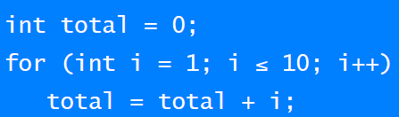

Summing the integer 1 to 10 in Haskell (The computation method is **function application**):



## History

* 1930s: Alonzo Church develops the lambda calculus, a simple but powerful theory of functions.
* 1950s: John McCarthy develops Lisp, the first functional language, with some influences from the lambda calculus, but retaining variable assignments.
* 1960s: Peter Landin develops ISWIM, the first pure functional language, based strongly on the lambda calculus, with no assignments.
* 1970s: John Backus develops FP, a functional language that emphasizes higher-order functions and reasoning about programs.
* 1970s: Robin Milner and others develop ML, the first modern functional language, which introduced type inference and polymorphic types.
* 1970s – 1980s: David Turner develops a number of lazy functional languages, culminating in the Miranda system.
* 1987: An international committee starts the development of Haskell, a standard lazy functional language.
* 1990s: Phil Wadler and others develop type classes and monads, two of the main innovations of Haskell.
* 2003: The committee publishes the Haskell Report, defining a stable version of the language; an updated version was published in 2010.
* 2010 – today: Haskell Platform - Standard distribution, library support, new language features, development tools, use in industry, influence on other languages, etc.

## Glasgow Haskell Compiler

* GHC is the leading implementation of Haskell, and comprises a compiler and interpreter;
* The interactive nature of the interpreter makes it well suited for teaching and prototyping;
* GHC is freely available from the Haskell website;

## Prelude

* Haskell comes with a large number of standard library functions. In addition to the familiar numeric functions such as + and *, the library also provides many useful functions on lists.

## Examples

* Select the first element of a list: head [1,2,3,4,5] 🡪 1
* Remove the first element of a list: tail [1,2,3,4,5] 🡪 [2,3,4,5]
* Select the nth element of a list: [1,2,3,4,5] !! 2 🡪 3
* Select the first n elements of a list: take 3 [1,2,3,4,5] 🡪 [1,2,3]
* Remove the first n elements from a list: drop 3 [1,2,3,4,5] 🡪 [4,5]
* Calculate the length of a list: length [1,2,3,4,5] 🡪 5
* Calculate the sum of a list of numbers: sum [1,2,3,4,5] 🡪 15
* Calculate the product of a list of numbers: product [1,2,3,4,5] 🡪 120
* Append two lists: [1,2,3] ++ [4,5] 🡪 [1,2,3,4,5]
* Reverse a list: reverse [1,2,3,4,5] 🡪 [5,4,3,2,1]

## Function Application

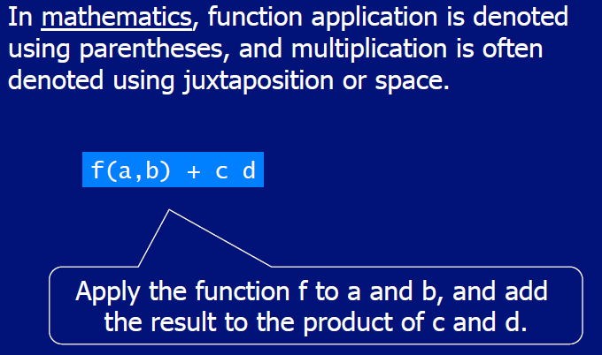

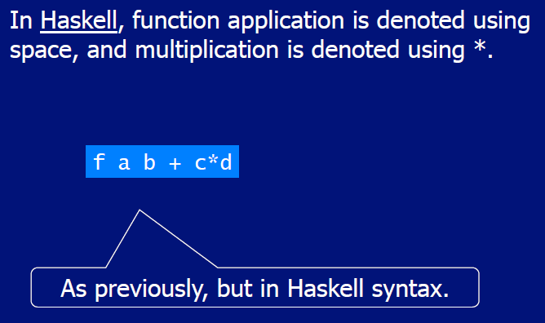

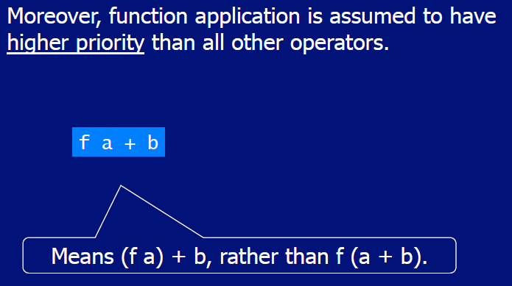

## Examples

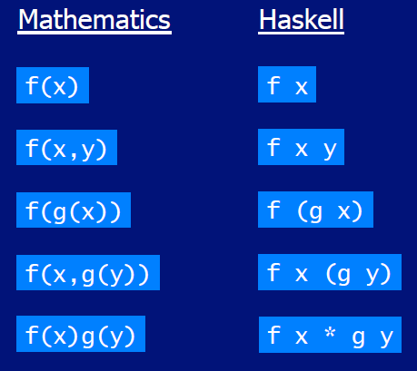

## Haskell Scripts

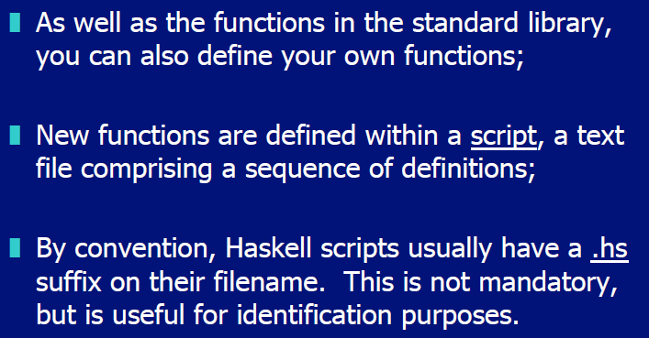

## GHCI Commands

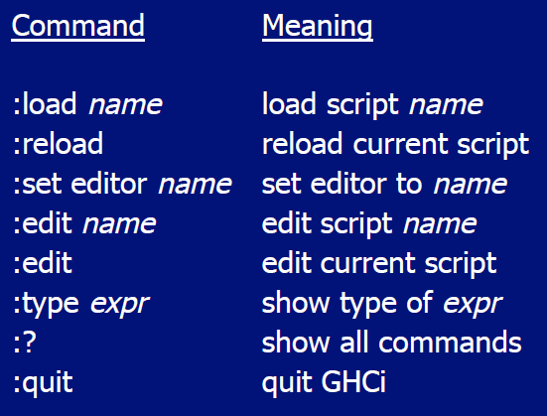

## Name Requirements

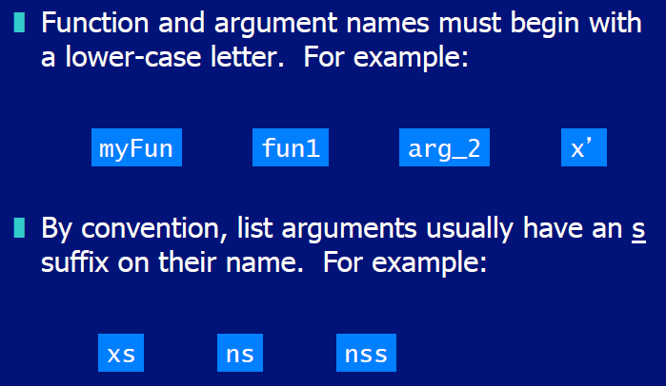

## Layout Rule

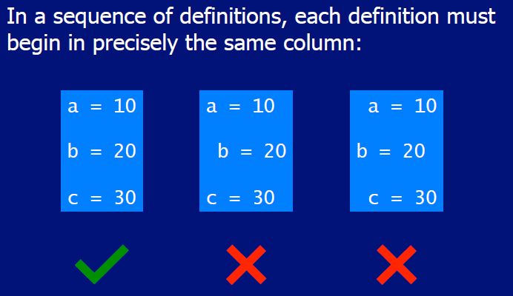

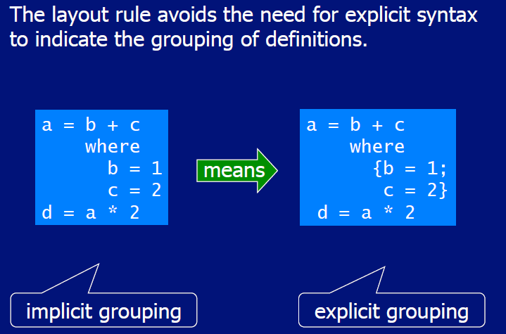

# Woche 2

## What is a Function?

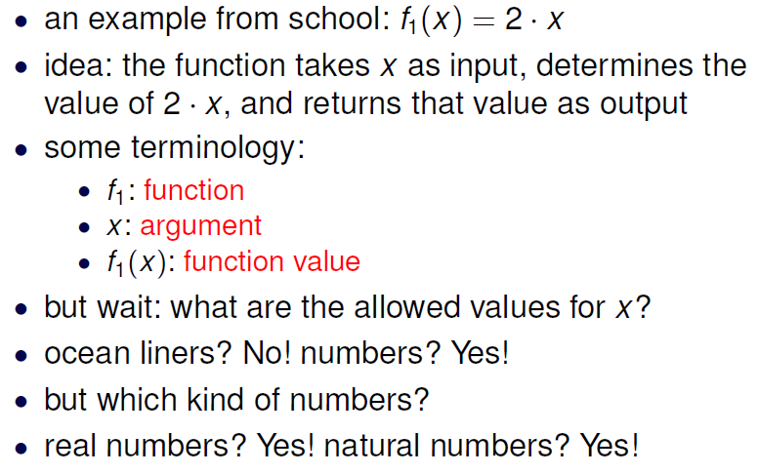

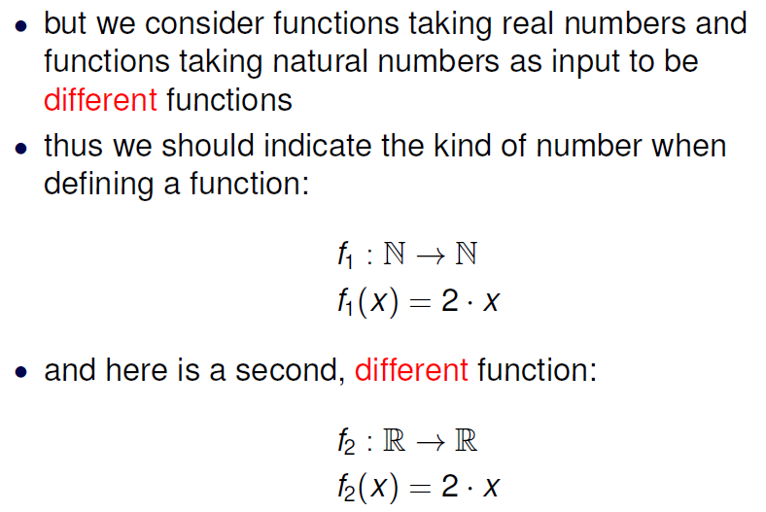

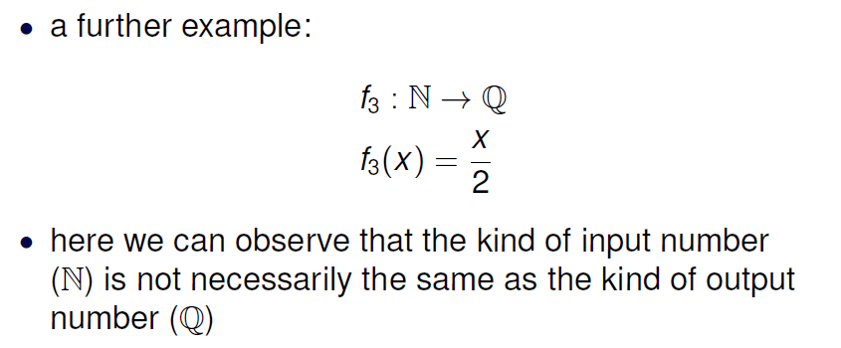

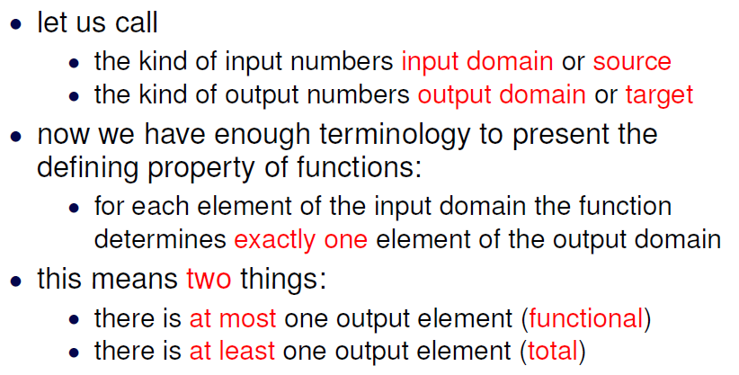

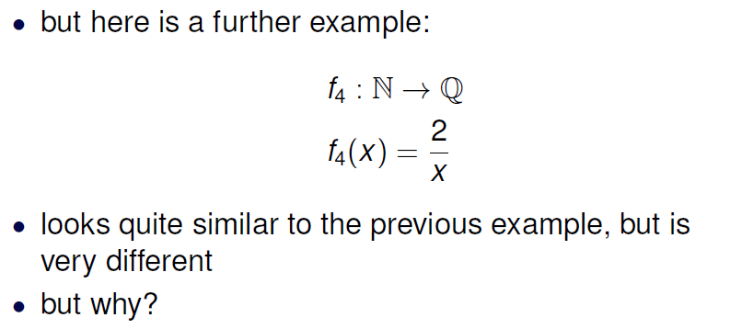

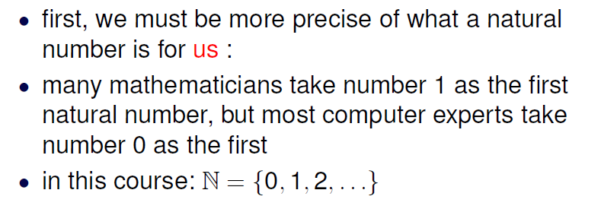

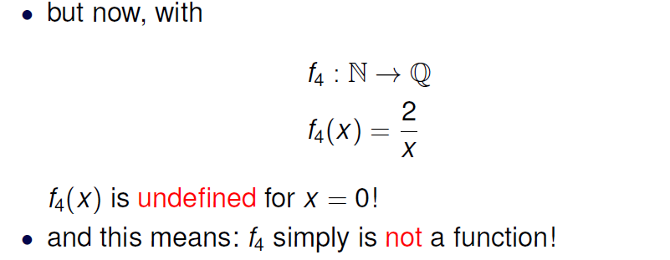

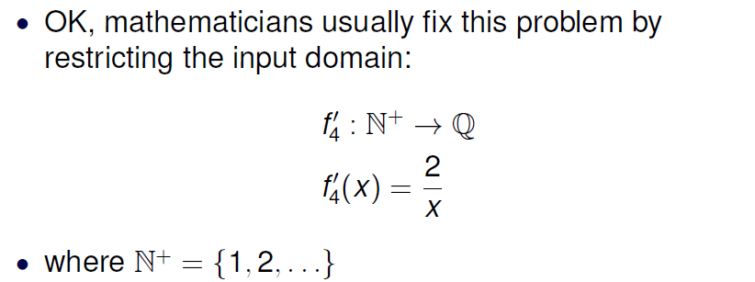

## What is a Partial Function?

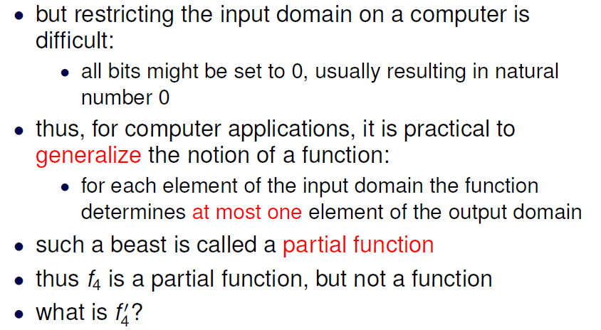

## Domain of Definition

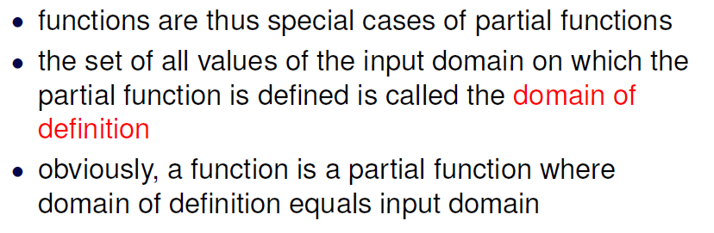

## Confusion

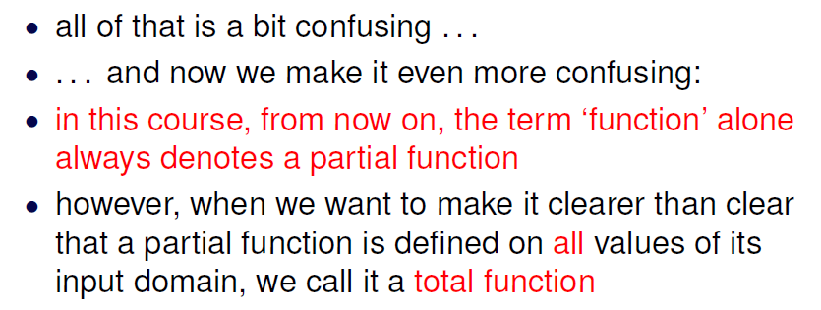

## Additional types

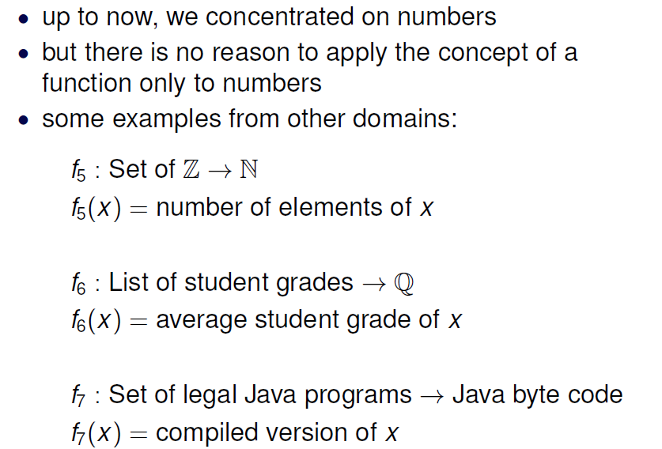

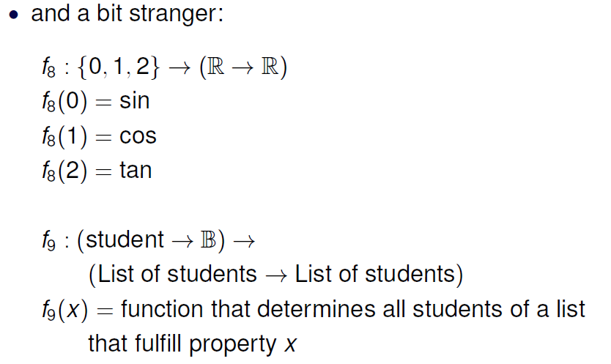

## Summary

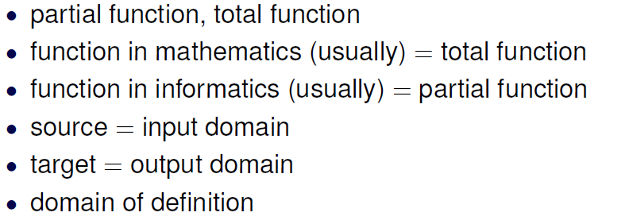

# Woche 3

## What is a Type

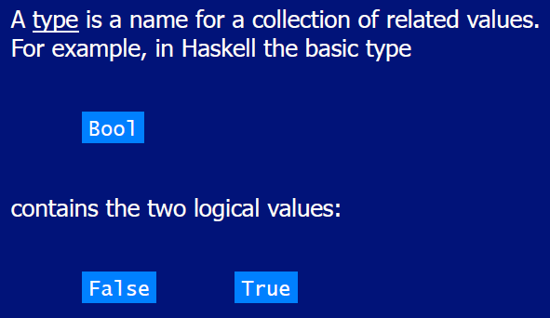

## Type Errors

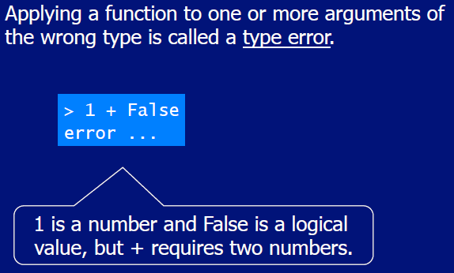

## Types in Haskell

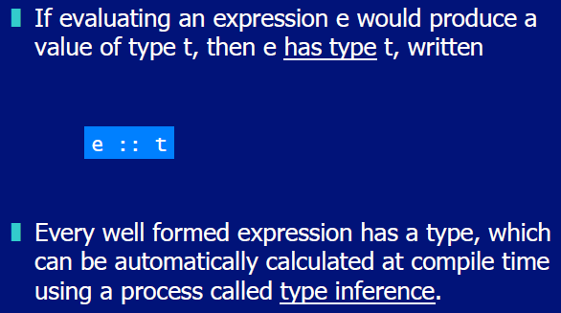

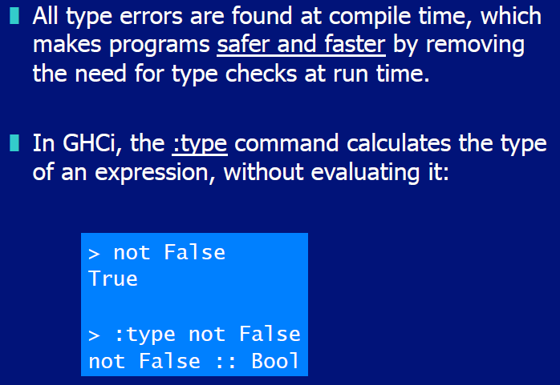

## Basic Types

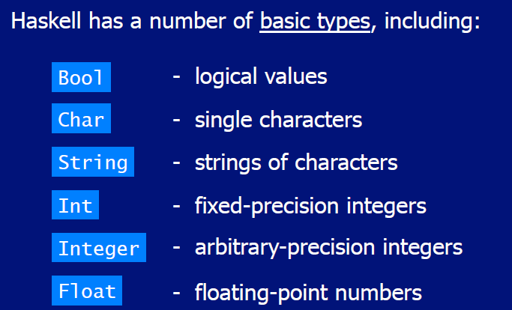

## List Types

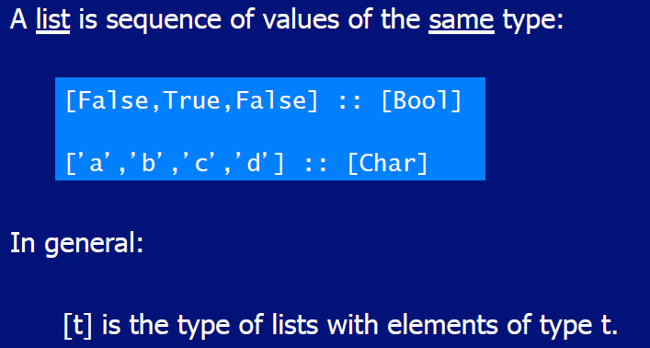

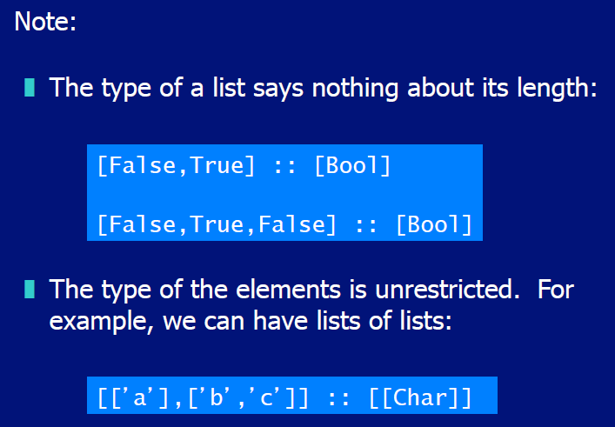

## Tuple Types

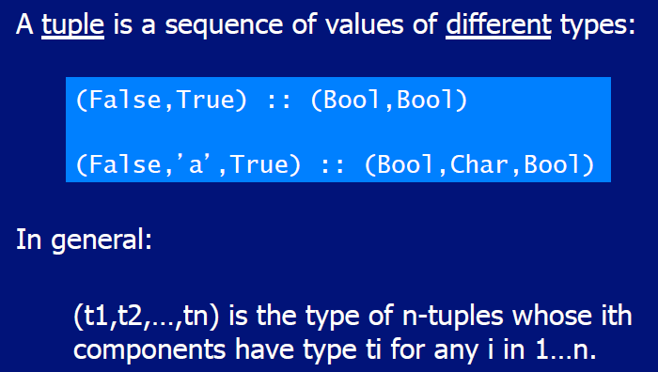

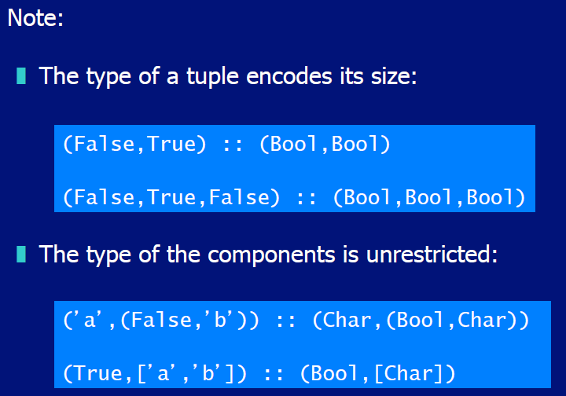

## Function Types

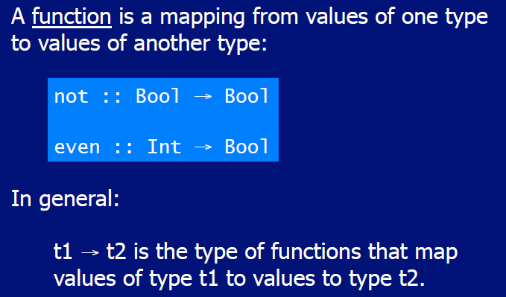

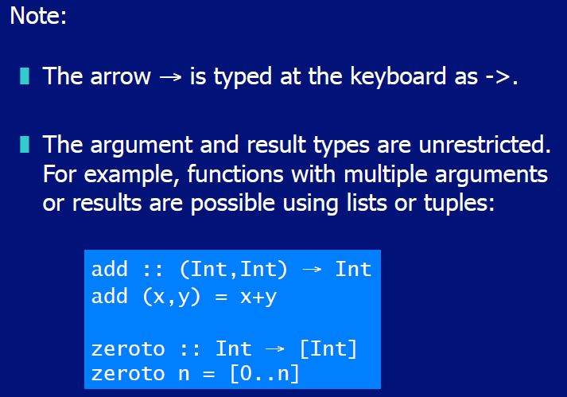

## Curried Functions

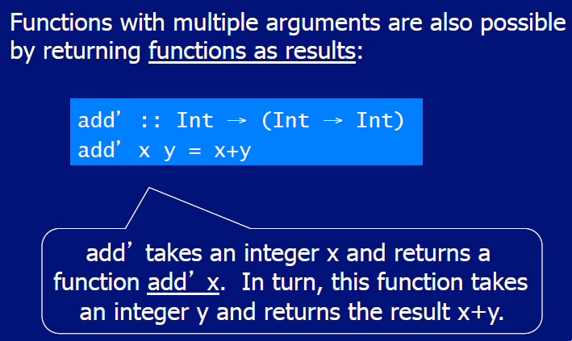

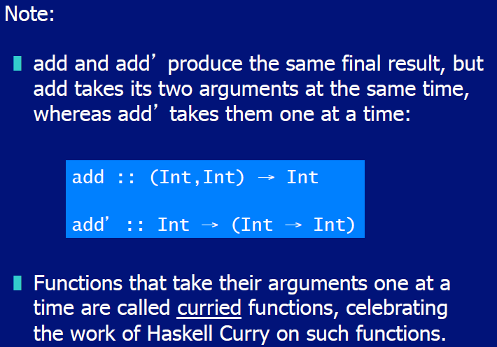

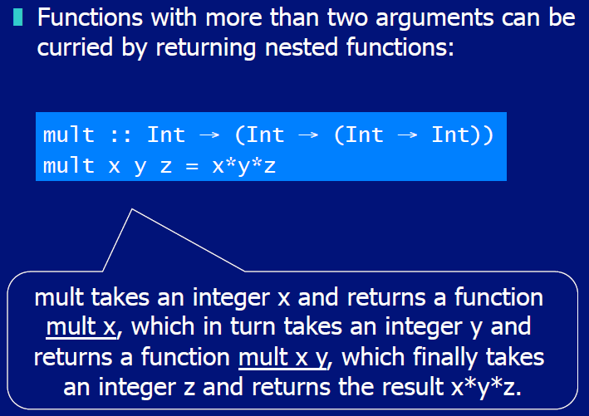

## Why is Currying useful

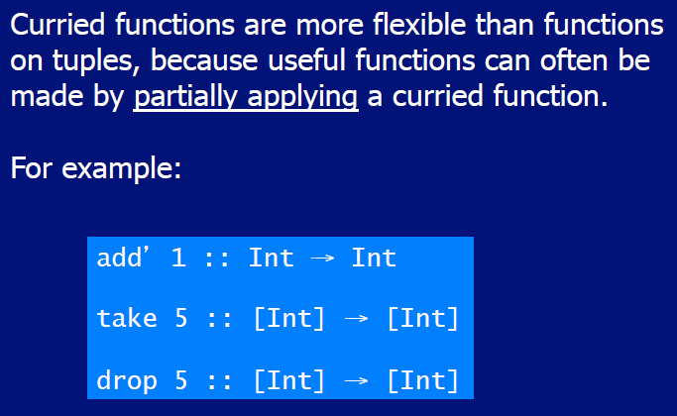

## Currying Conventions

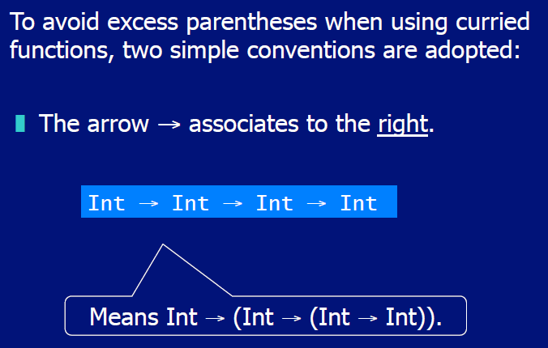

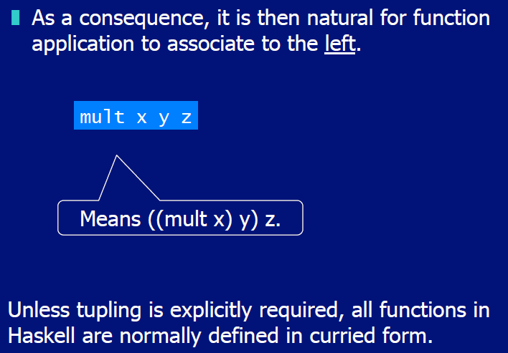

## Polymorphic Functions

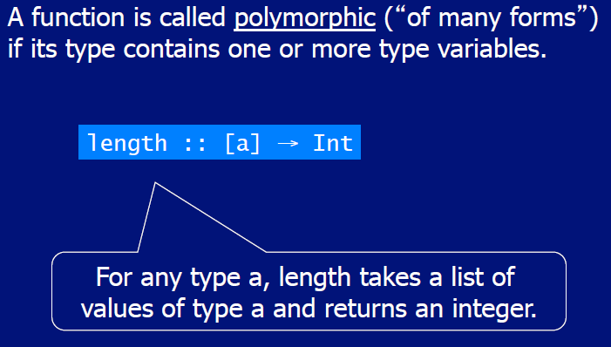

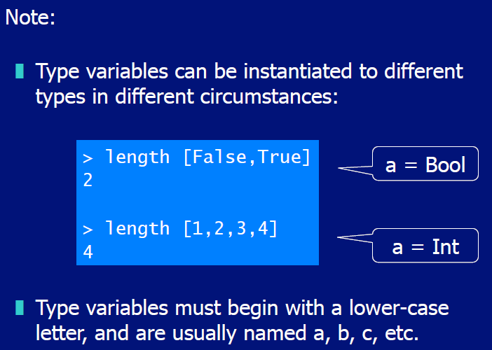

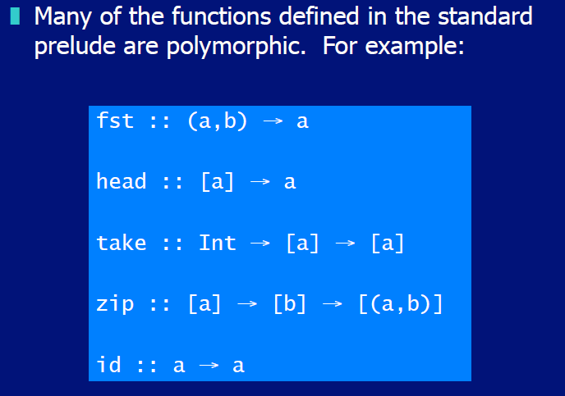

## Overloaded Functions

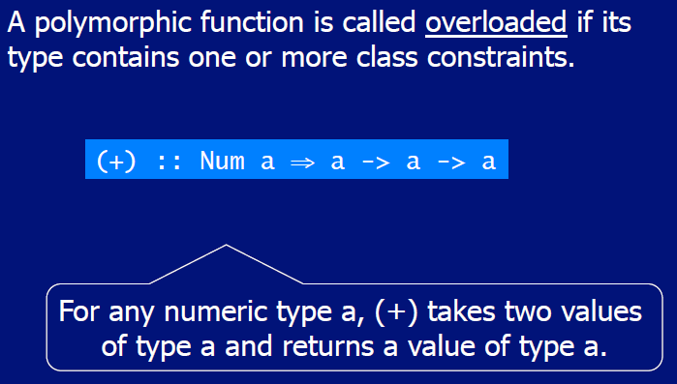

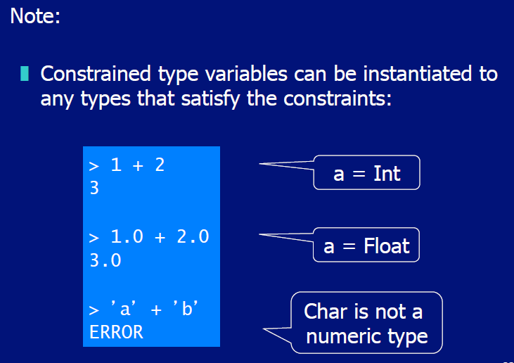

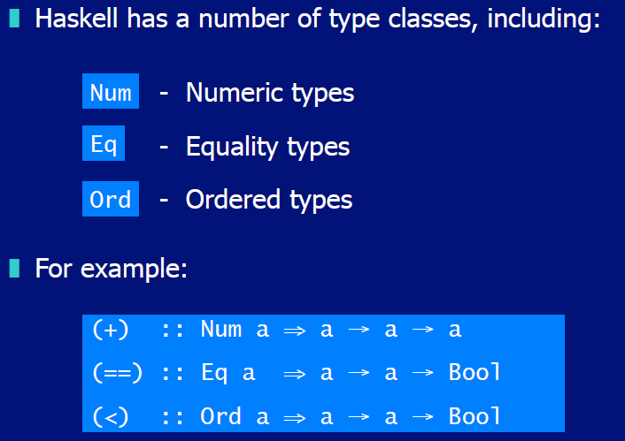

## Hints and Tips

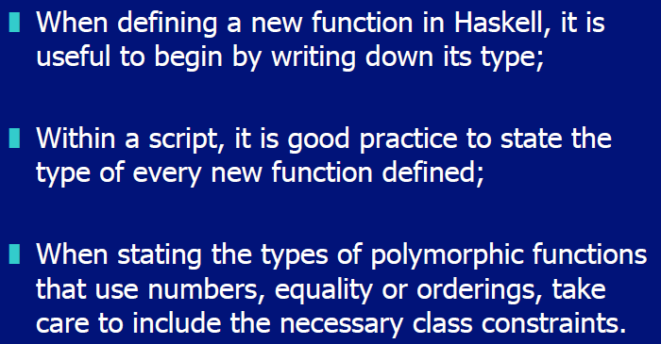

# Woche 4

## Typeclasses

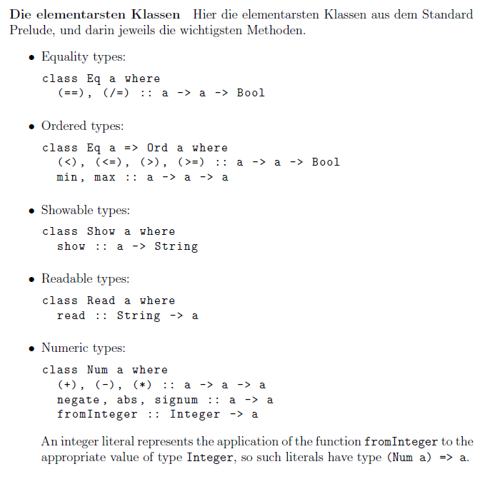

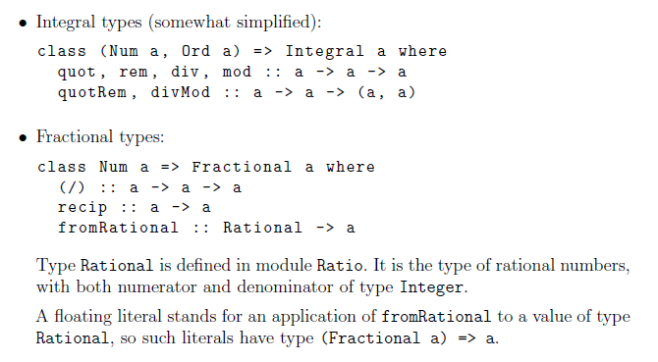

# Woche 5

## Conditional Expressions

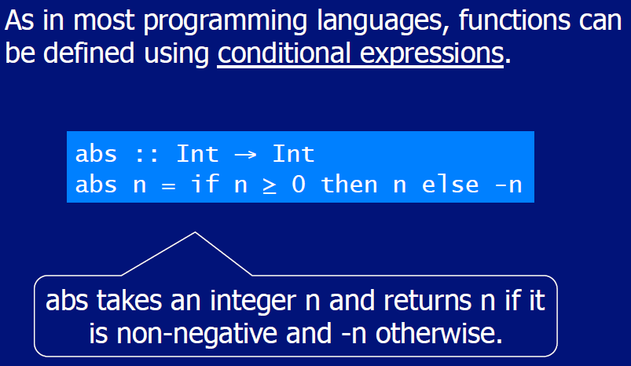

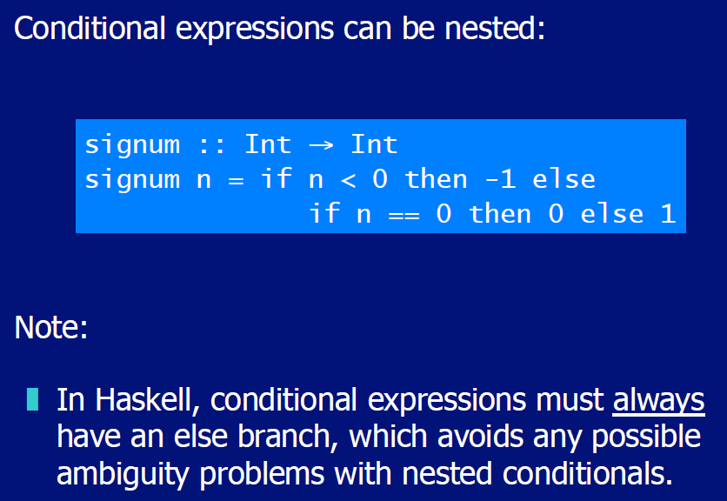

## Guarded Equations

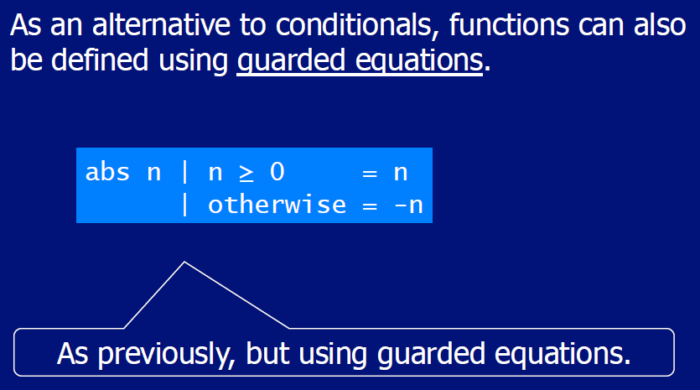

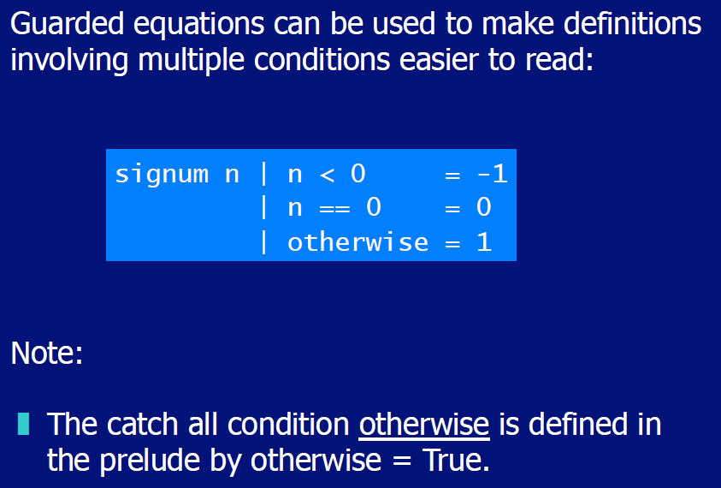

## Pattern Matching

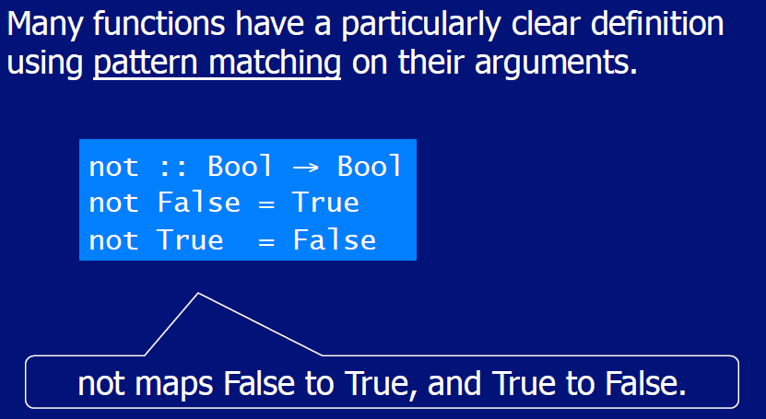

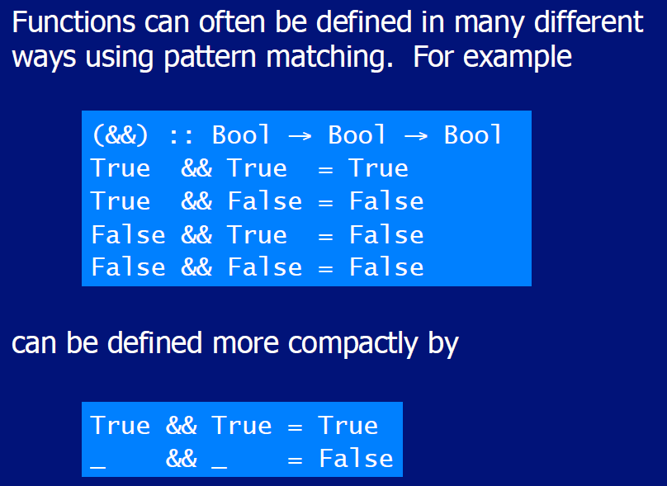

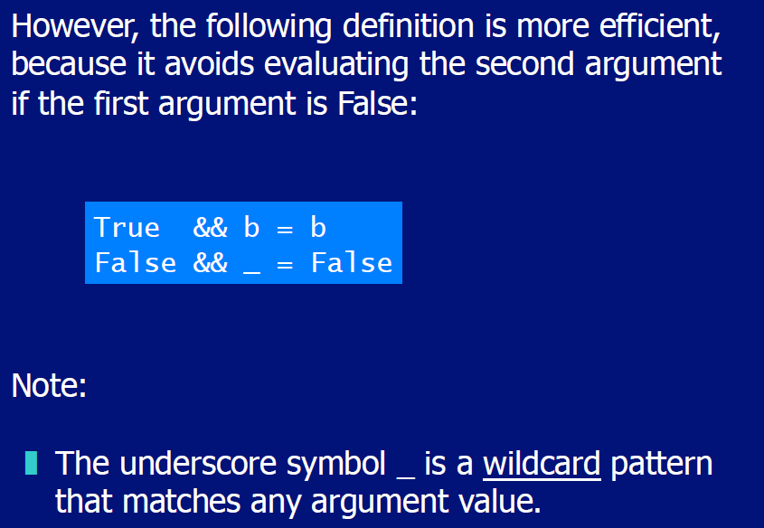

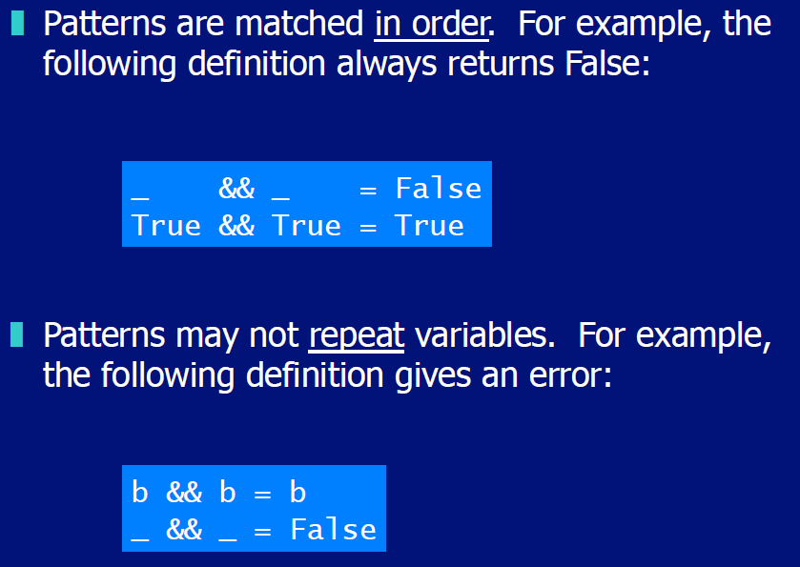

## List Patterns

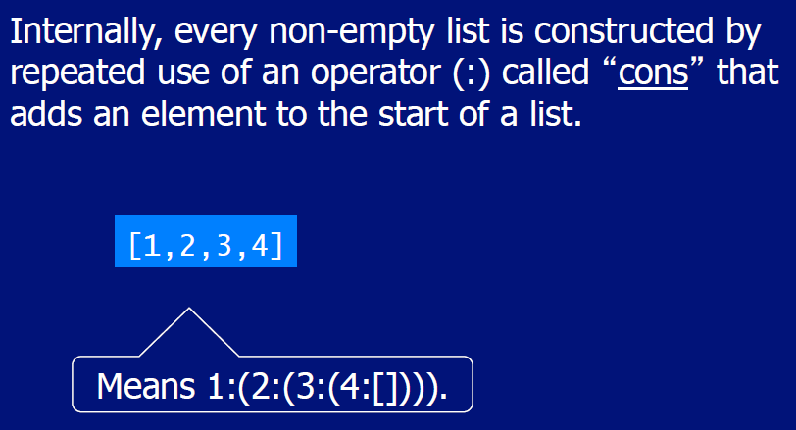

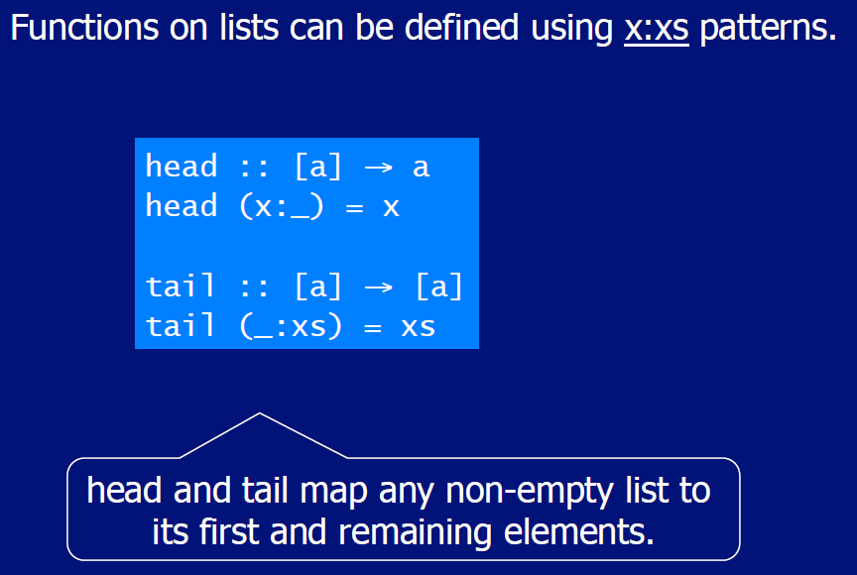

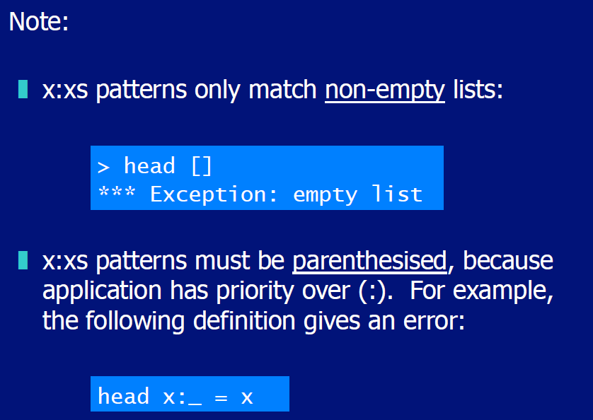

# Woche 6

## Lambda Expressions

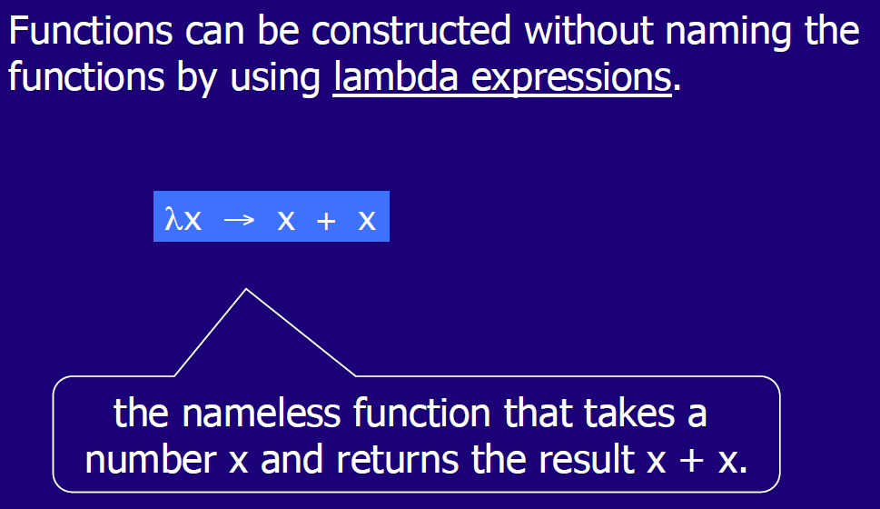

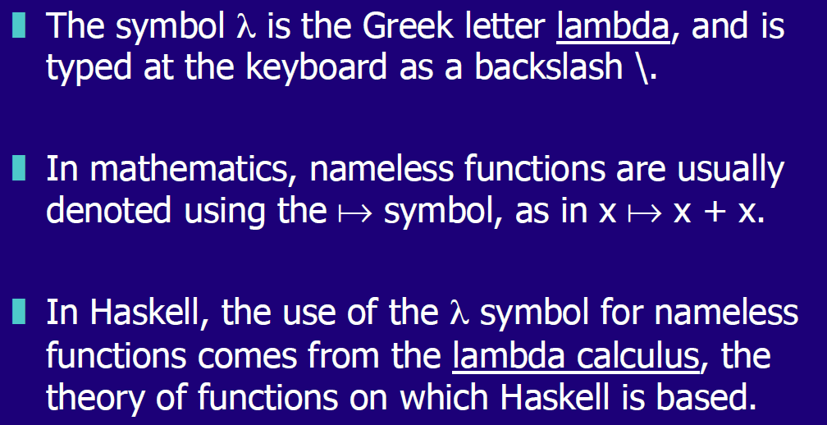

## Why are Lambdas useful

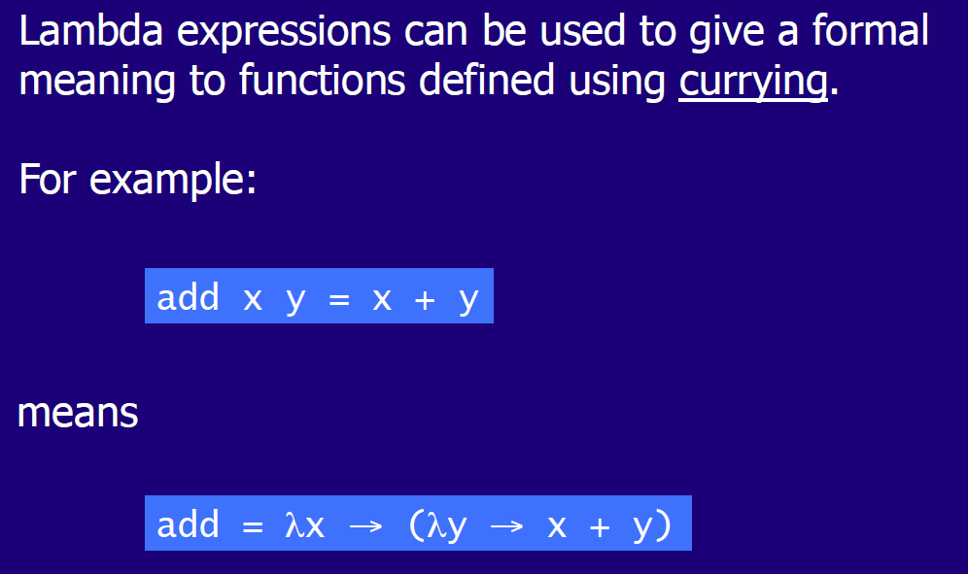

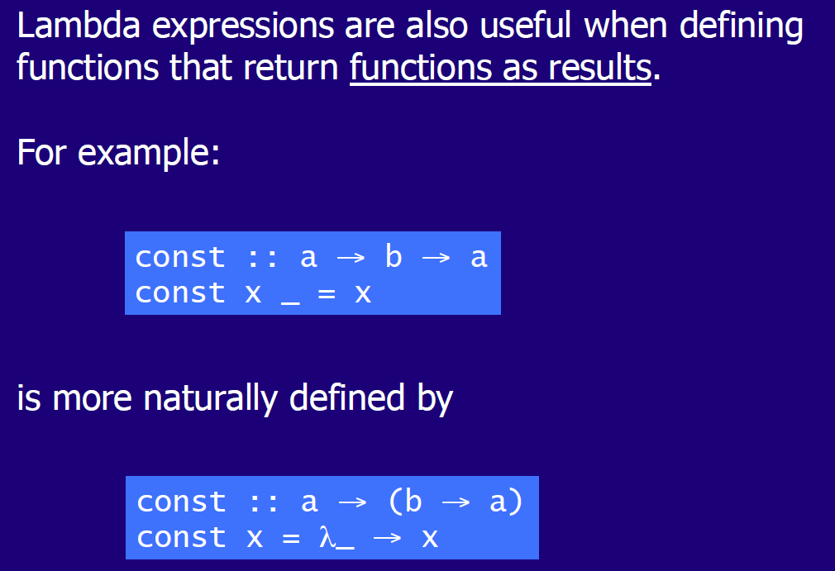

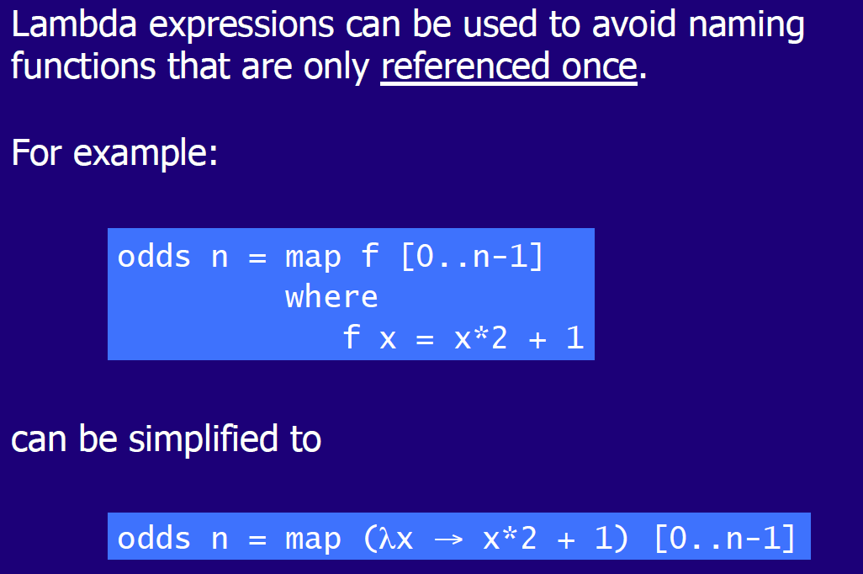

## Operator Sections

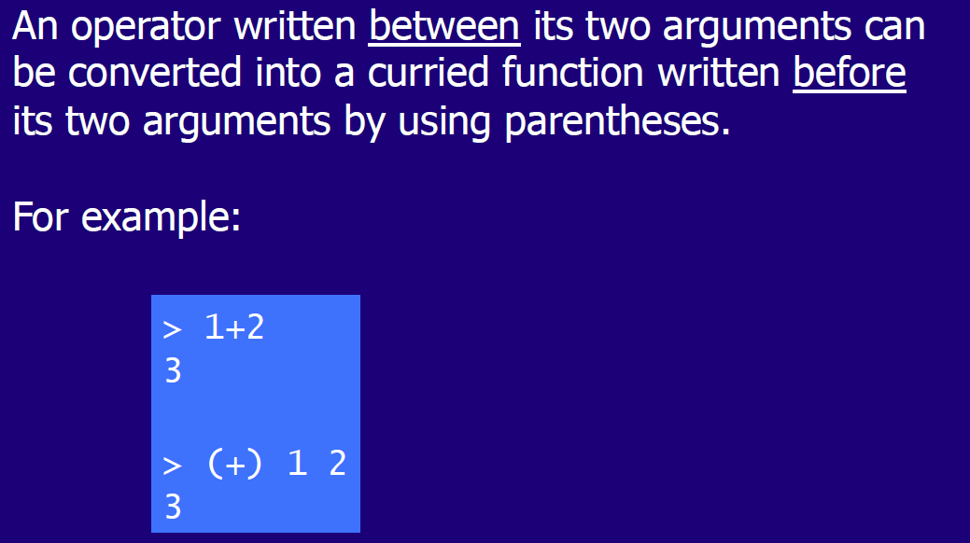

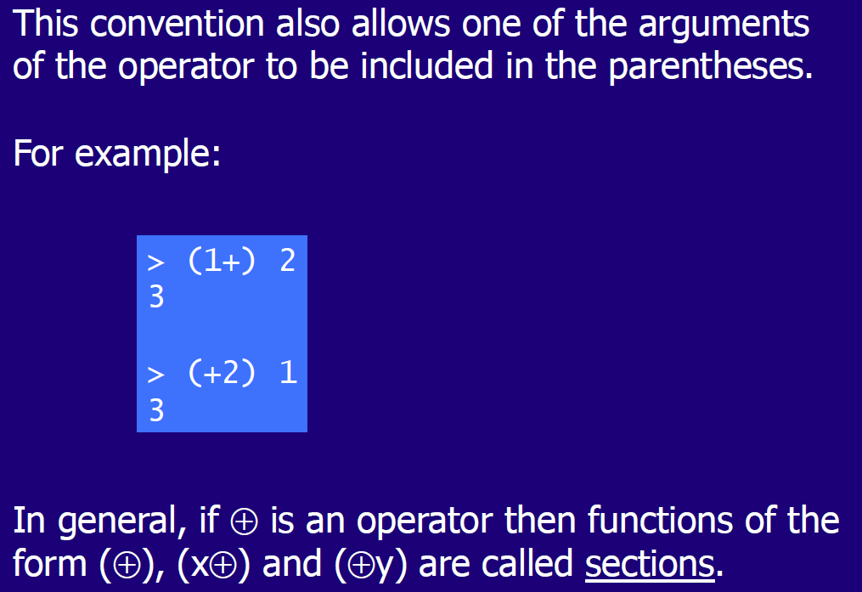

## Why are Sections useful

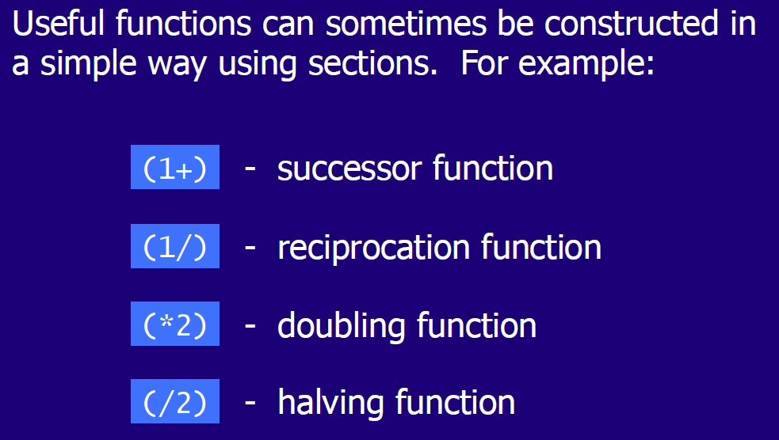

## Set Comprehensions

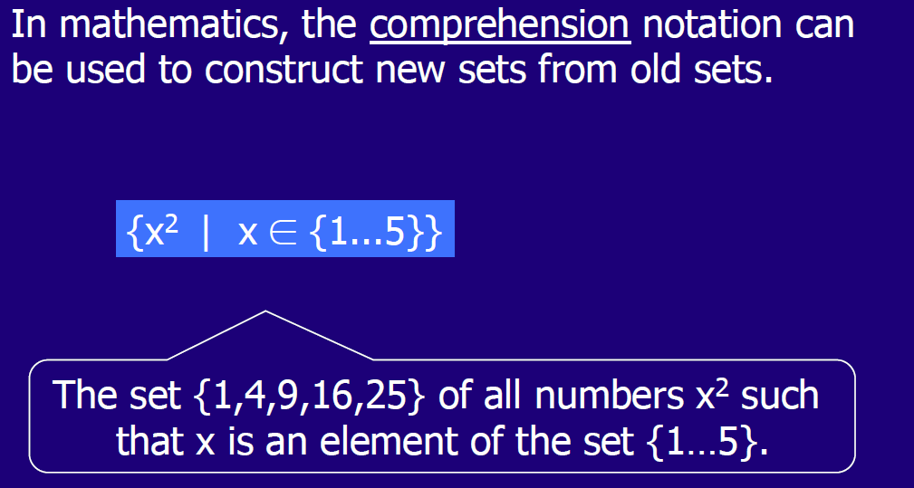

## List Comprehensions

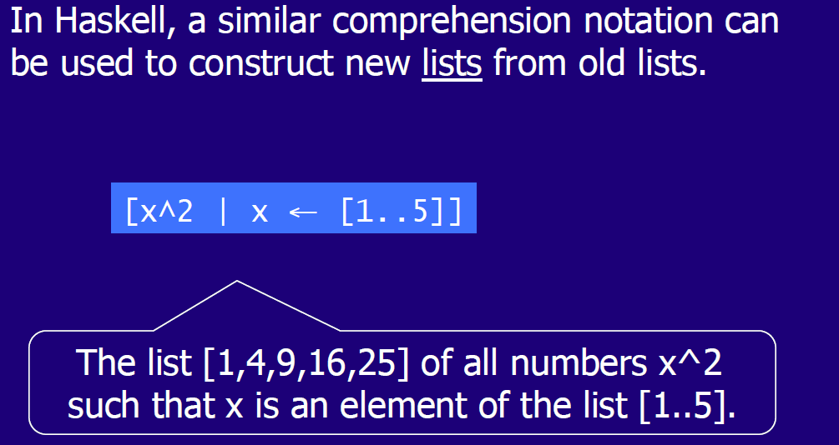

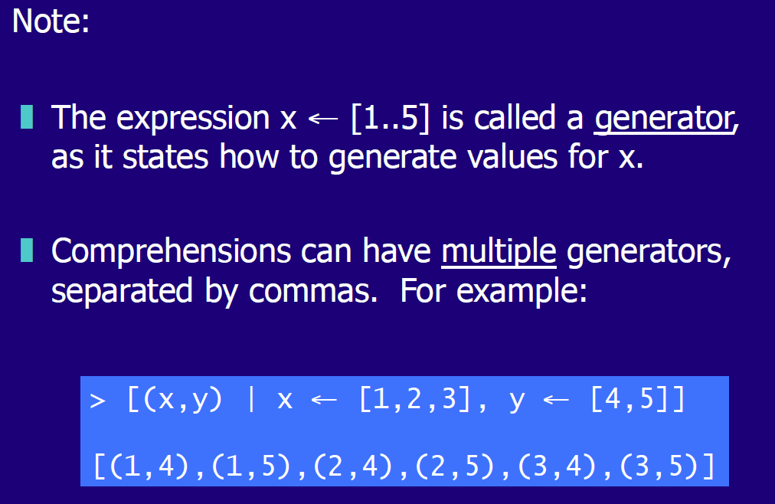

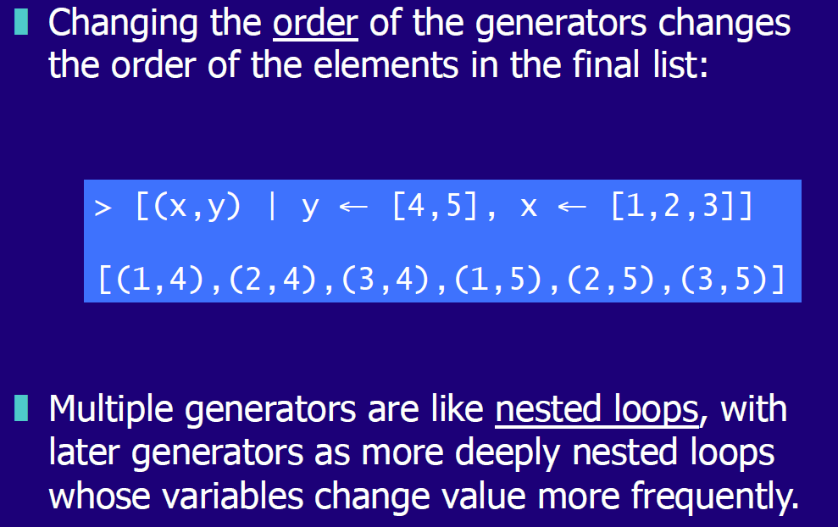

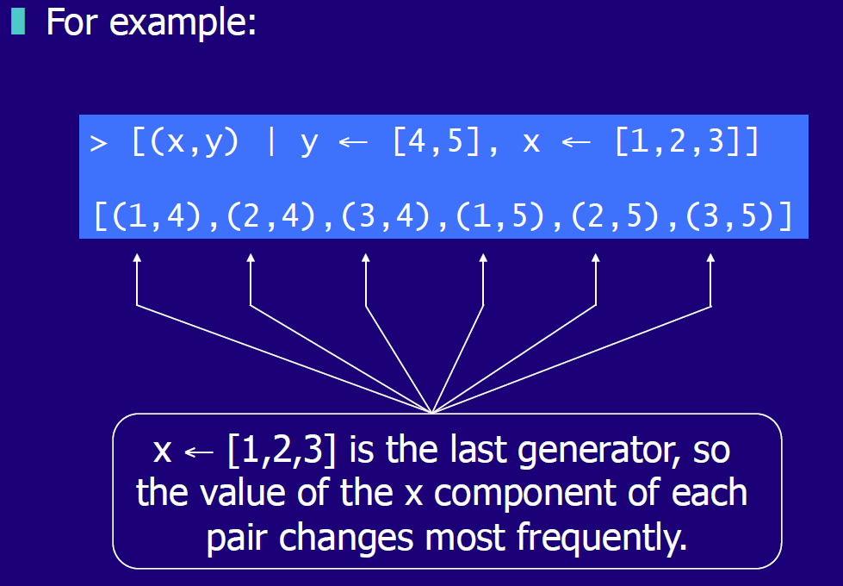

## Dependent Generators

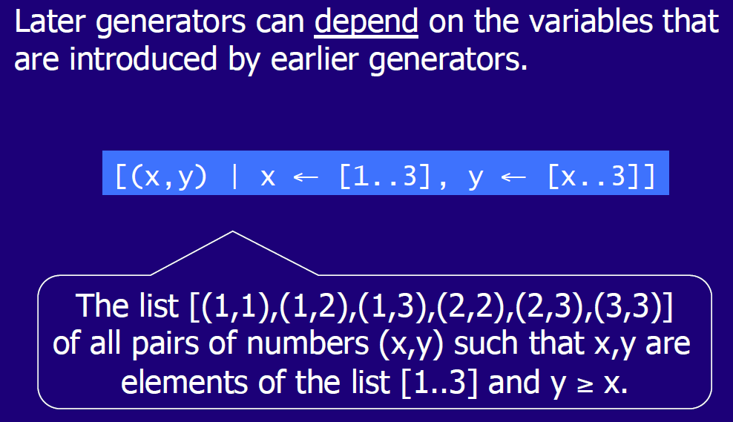

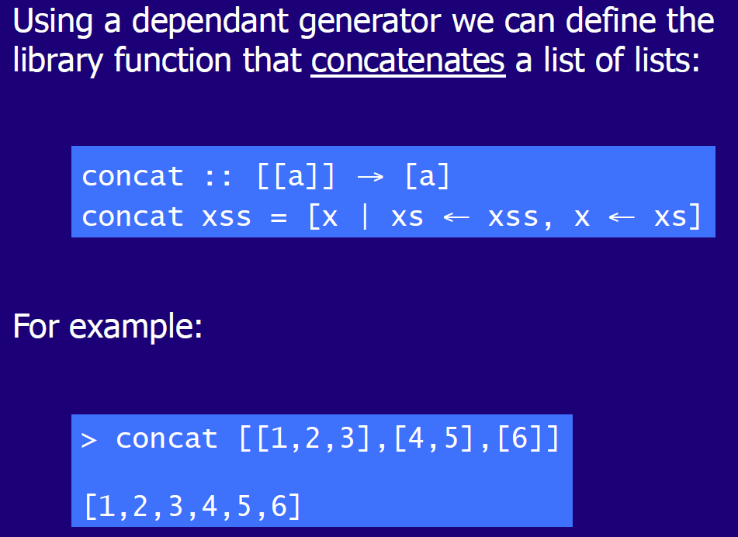

## Guards

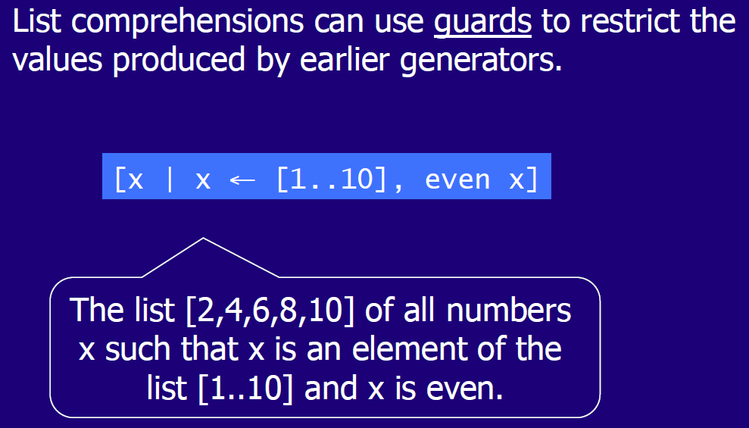

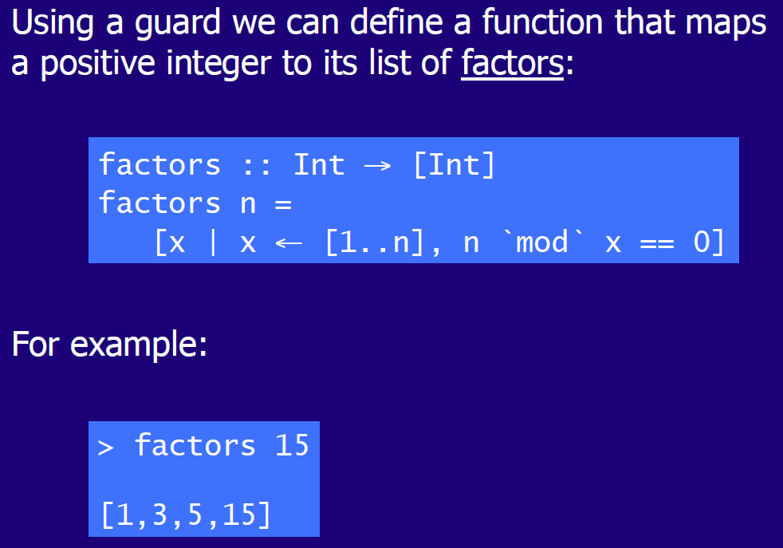

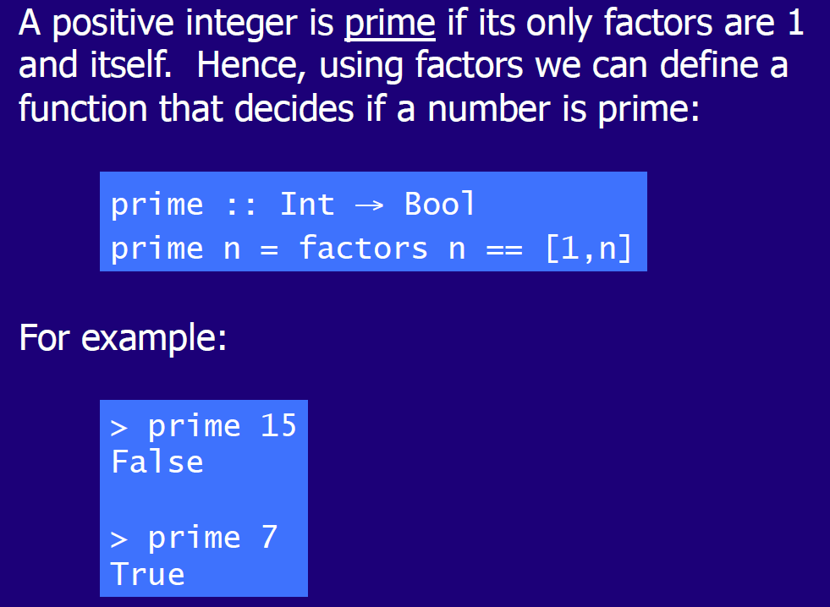

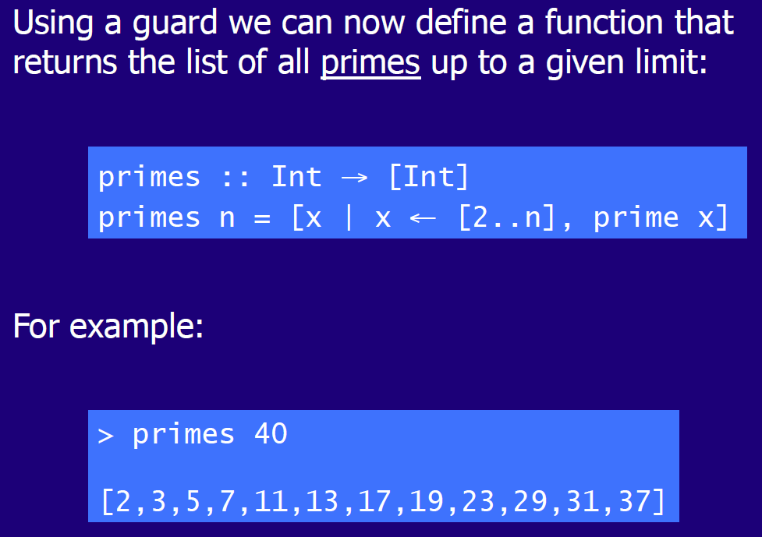

# Woche 7

## Zip Function

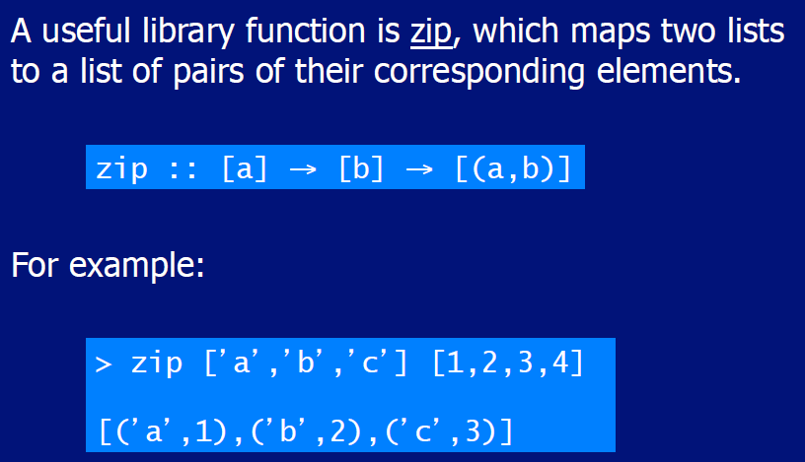

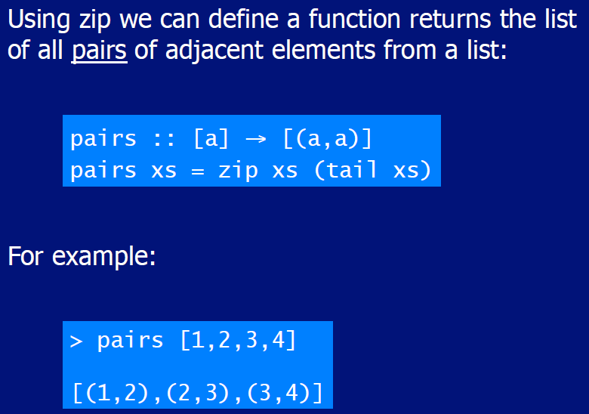

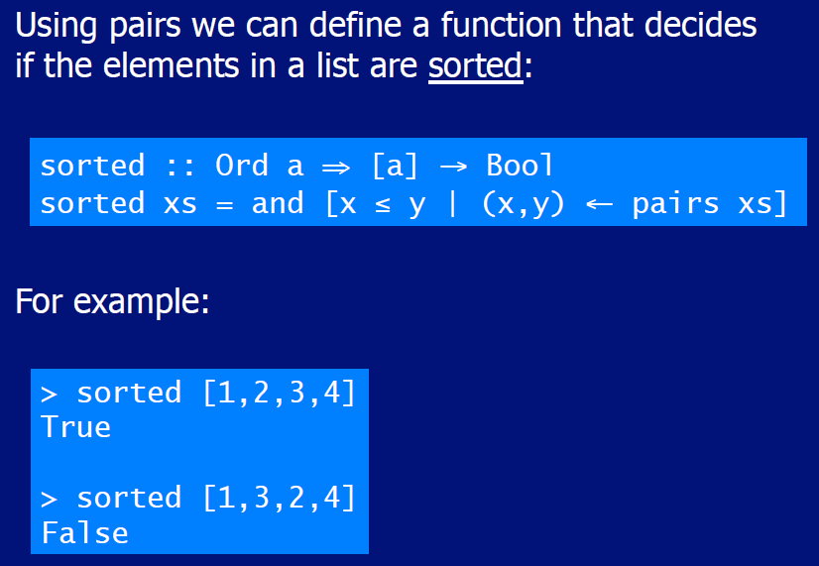

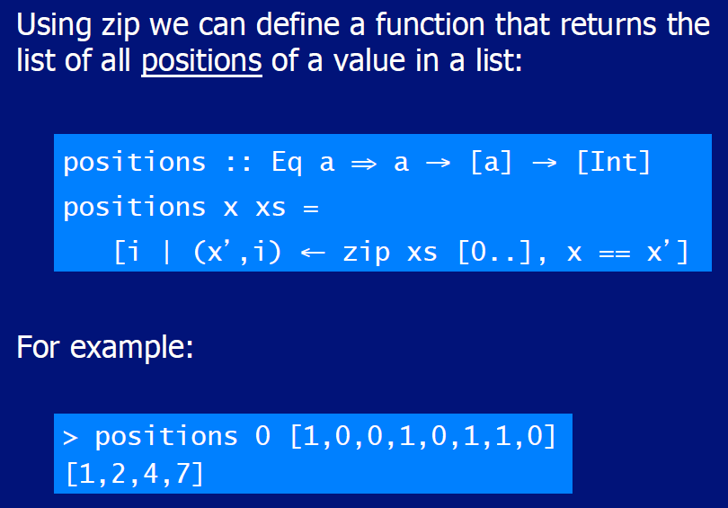

## String Comparison

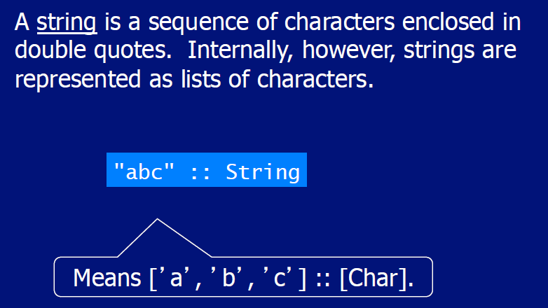

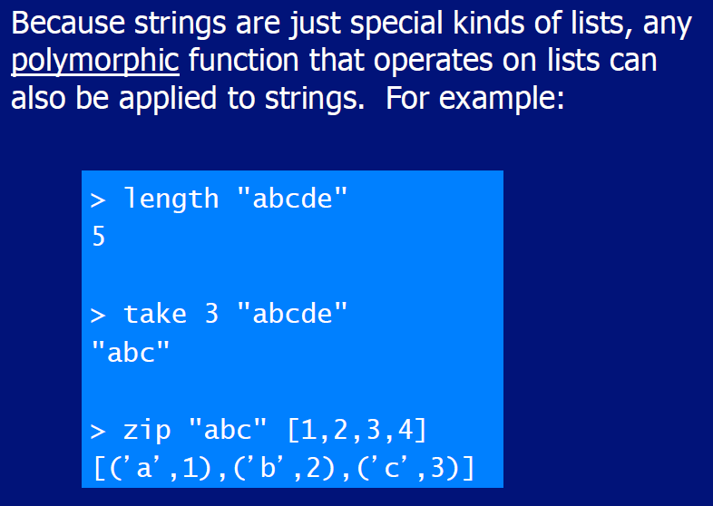

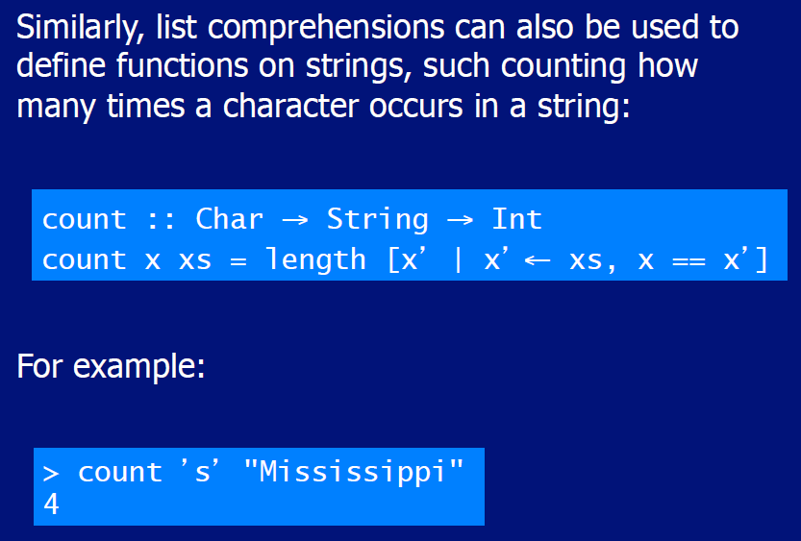

# Woche 8

In Woche 8 fand die erste Prüfung statt und somit fiel der Unterricht aus.

# Woche 9 & 10

## Introduction to Recursion

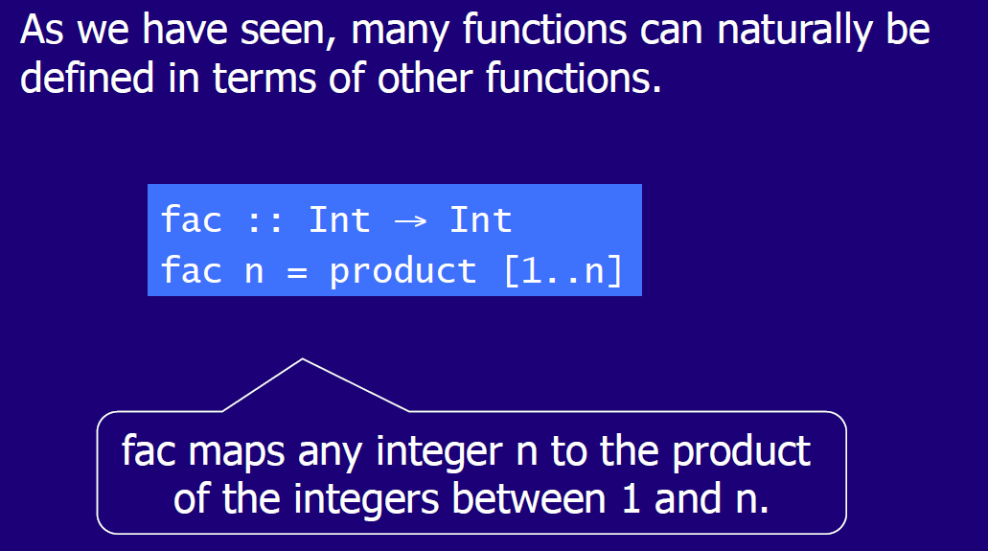

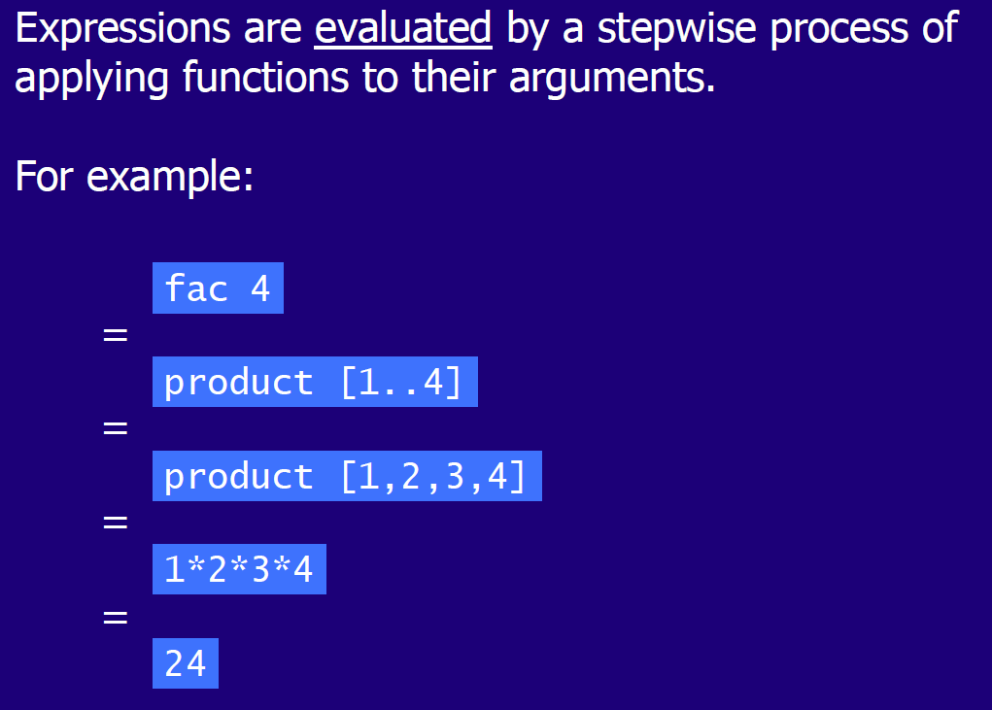

## Recursive Functions

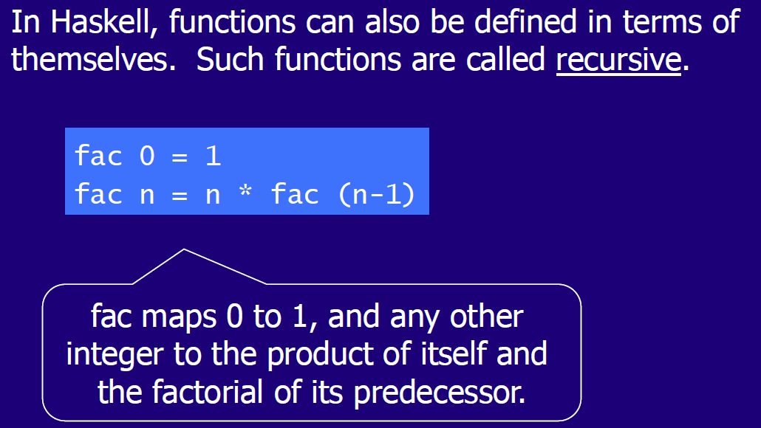

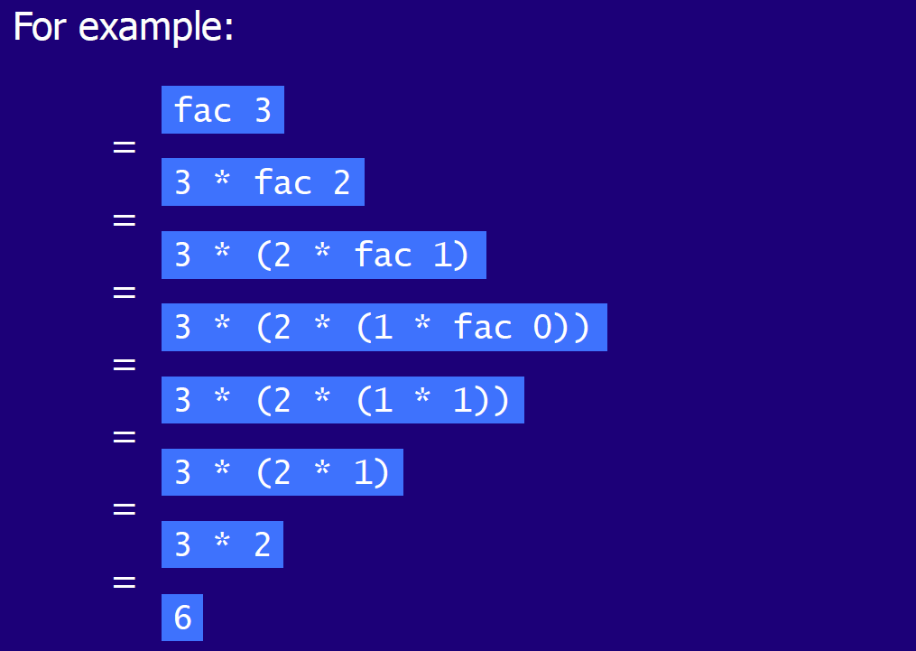

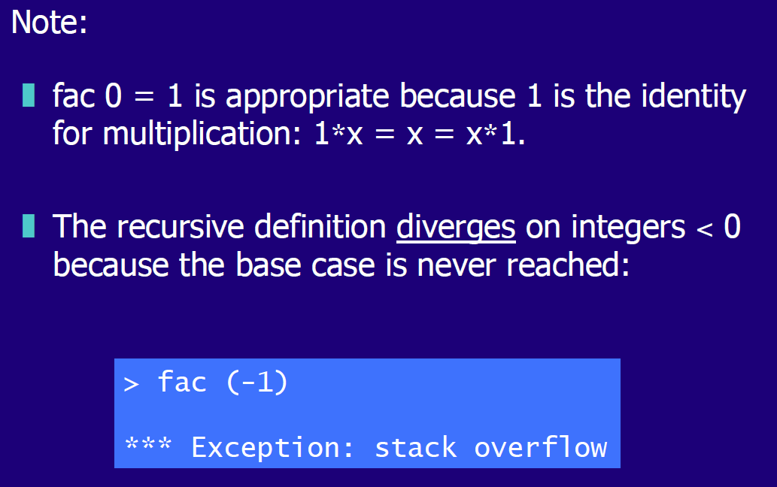

## Why is Recursion useful

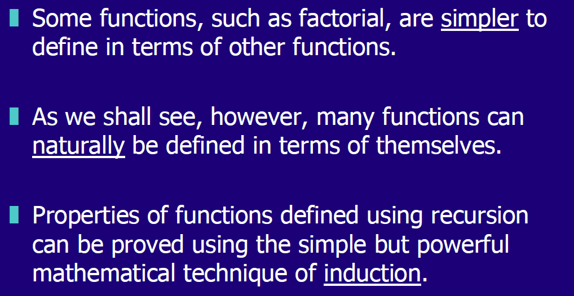

## Recursion on Lists

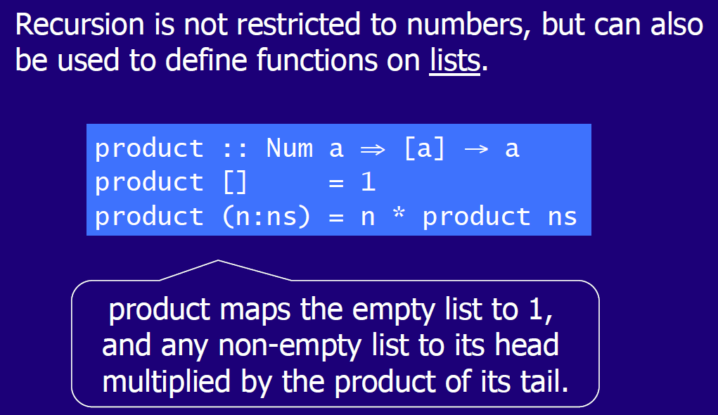

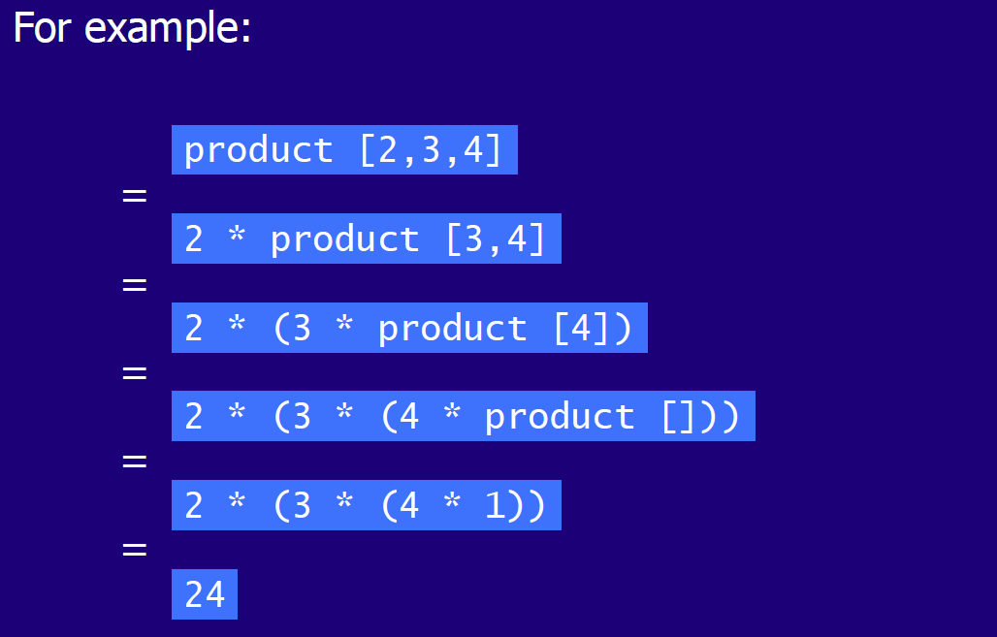

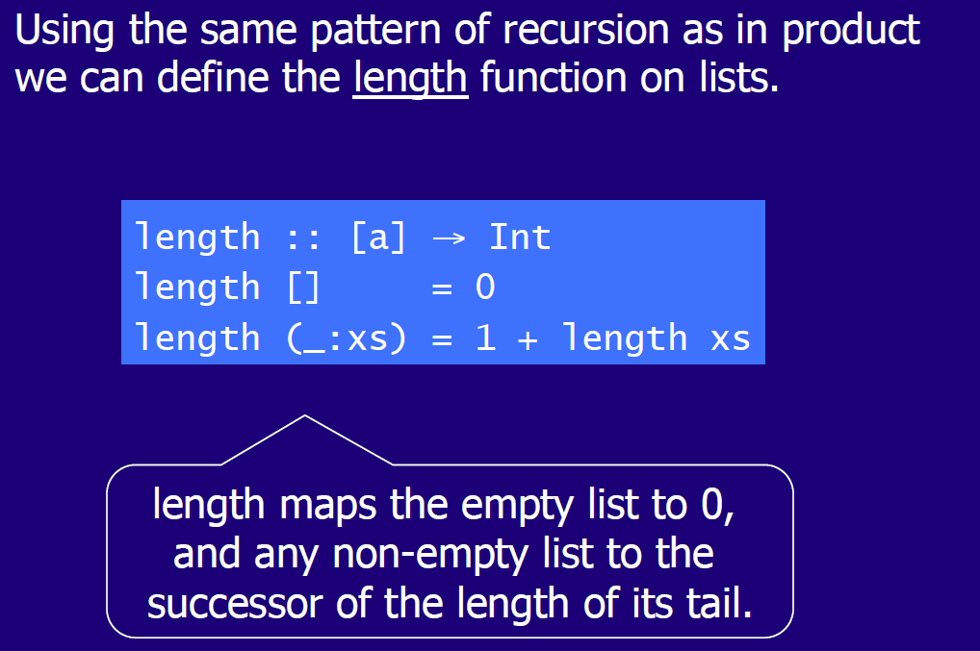

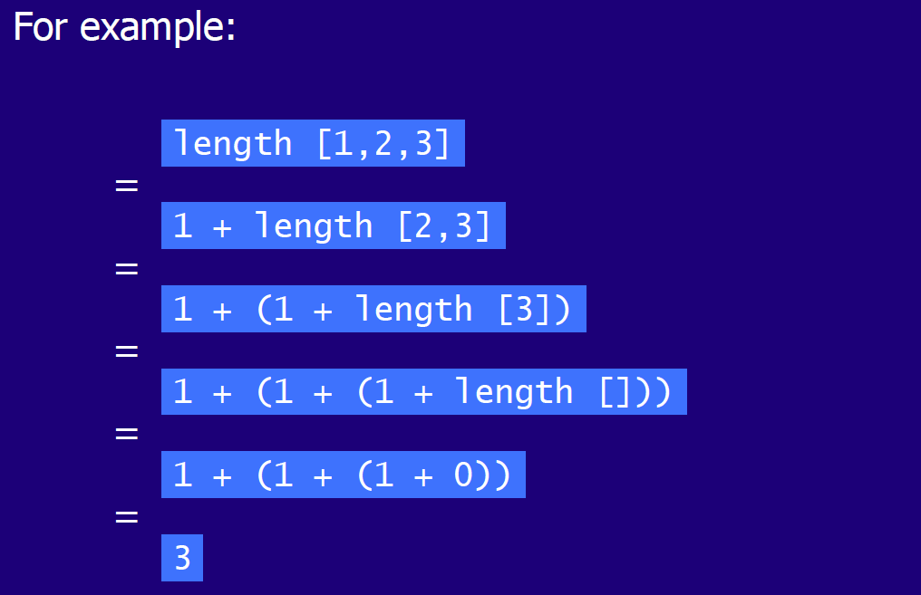

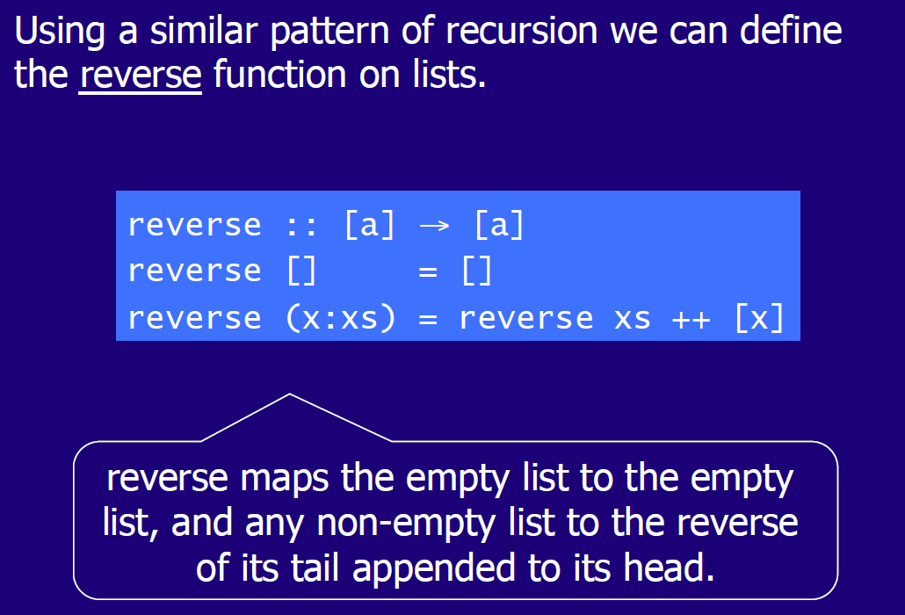

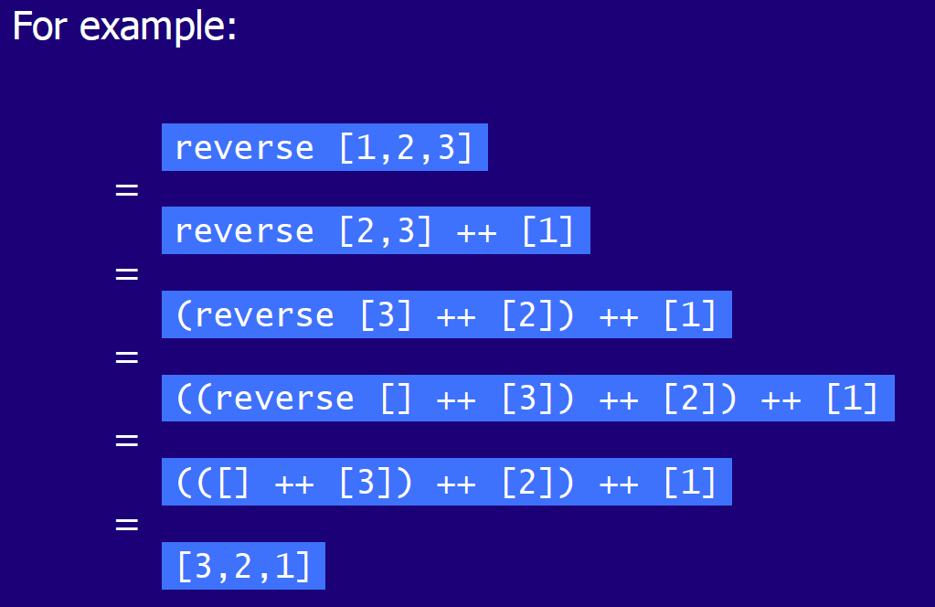

## Multiple Arguments

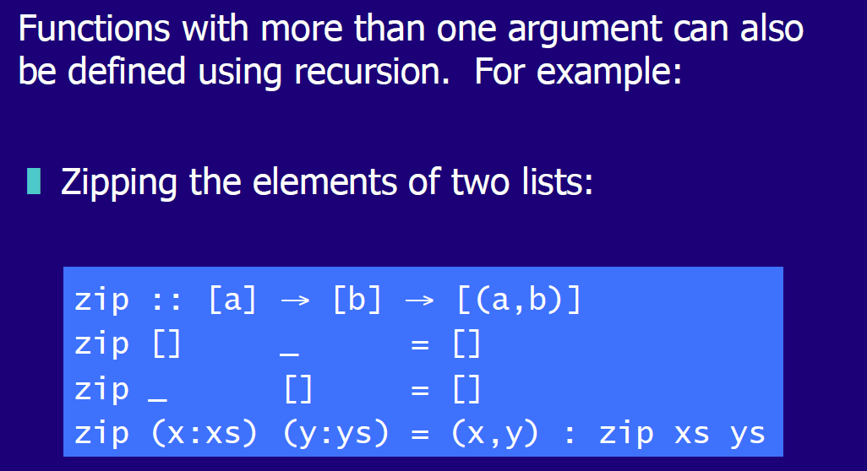

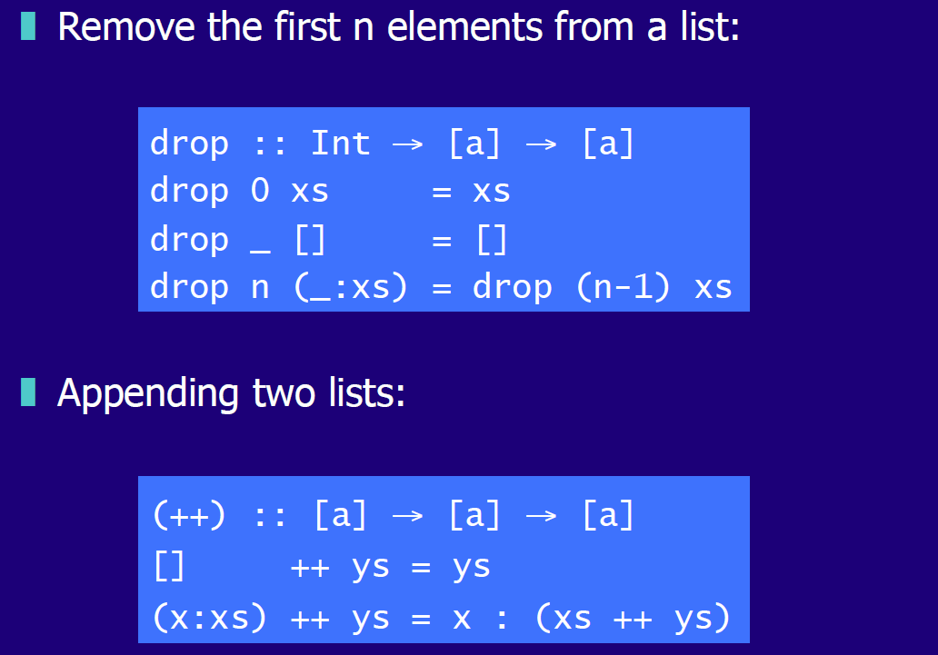

## Quicksort

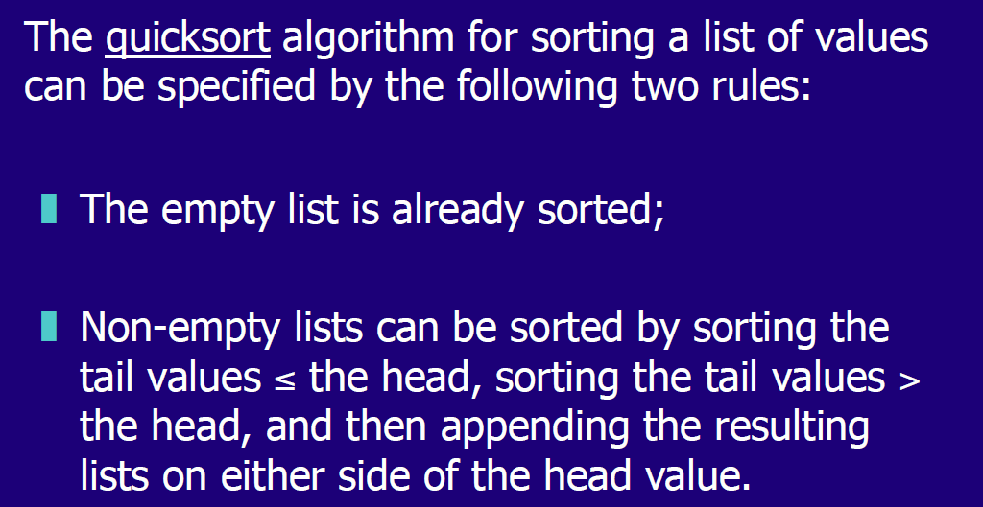

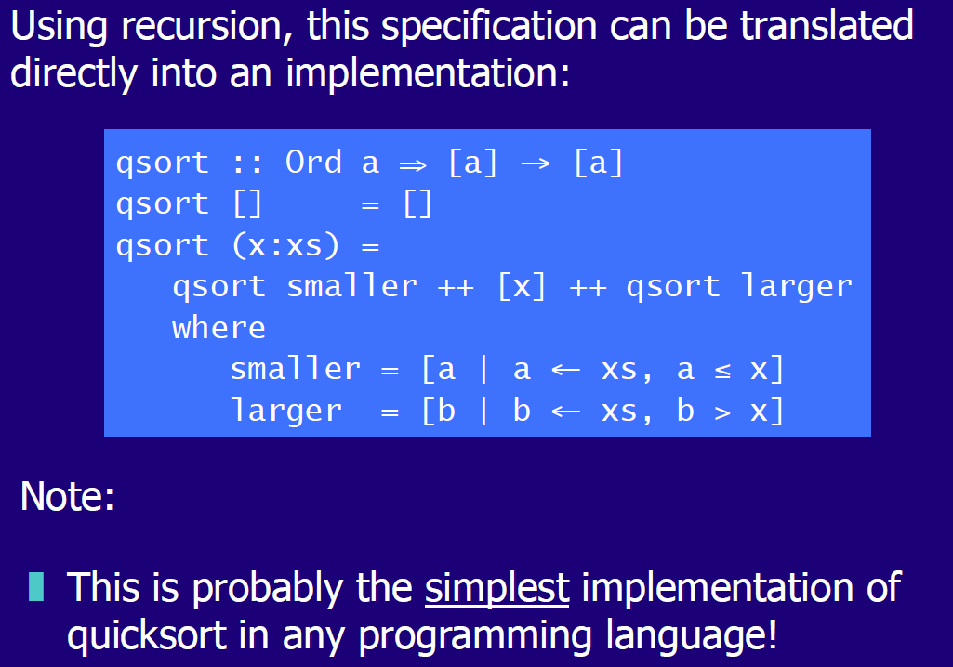

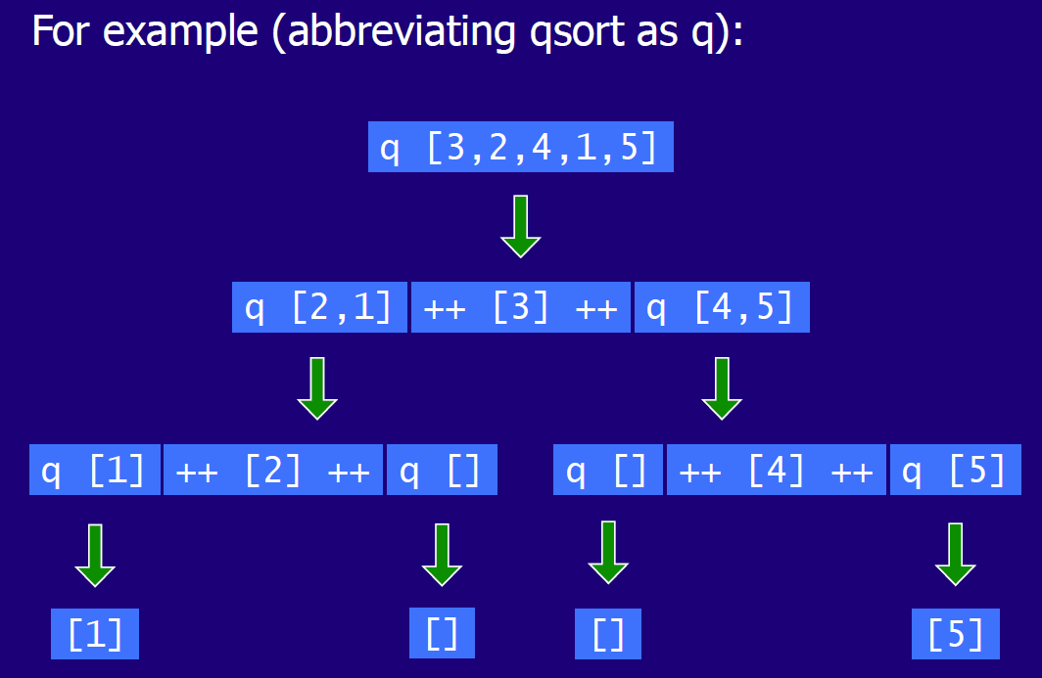

# Woche 11

In Woche 11 fand aufgrund der Projektwoche kein Unterricht statt.

# Woche 12 & 13 & 14

## Introduction to Higher Order Functions

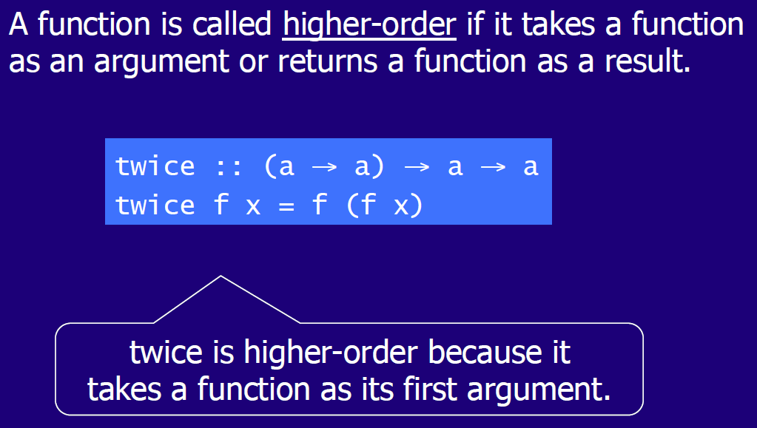

## Why are they useful

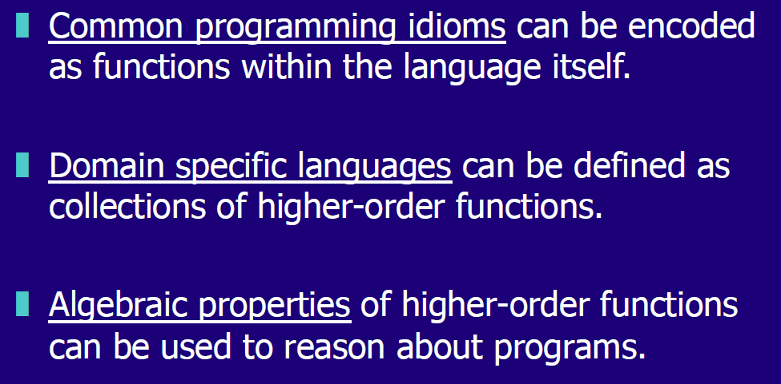

## Map Function

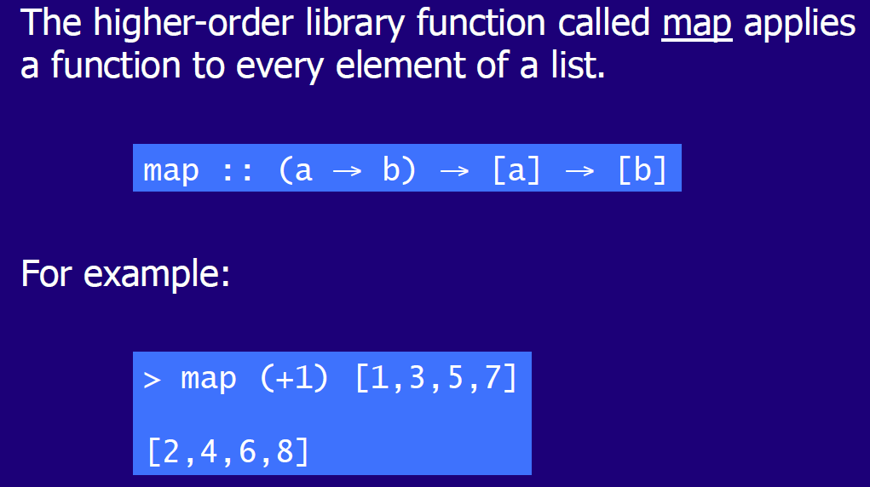

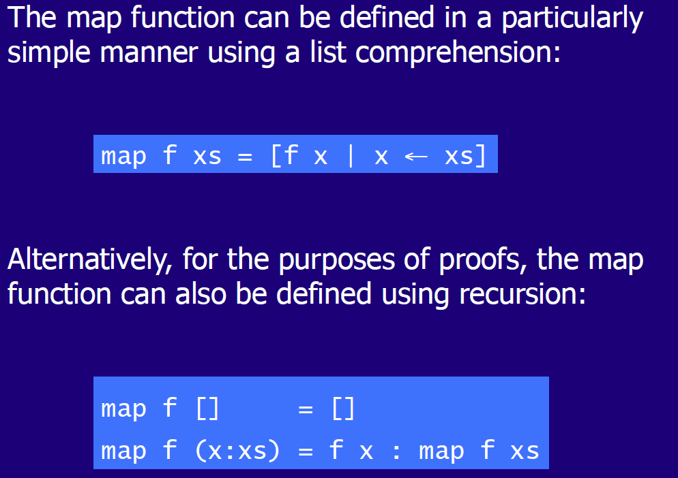

## Filter Function

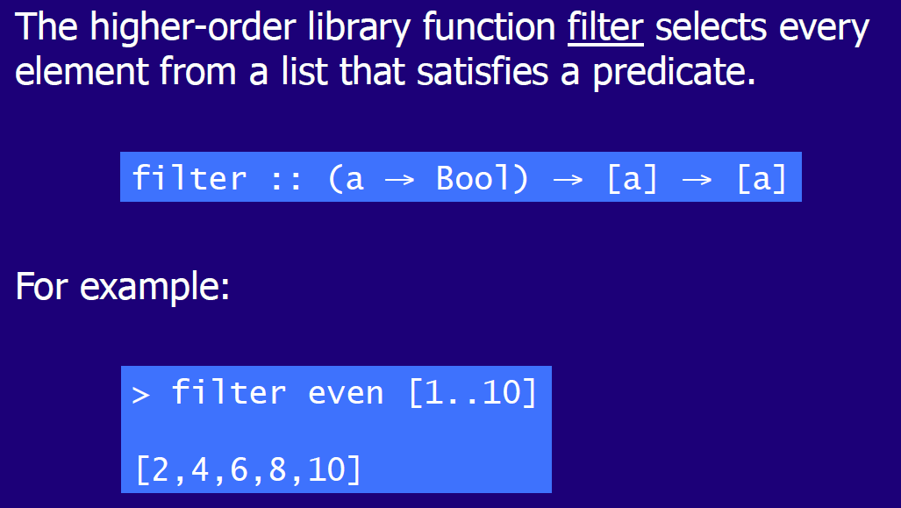

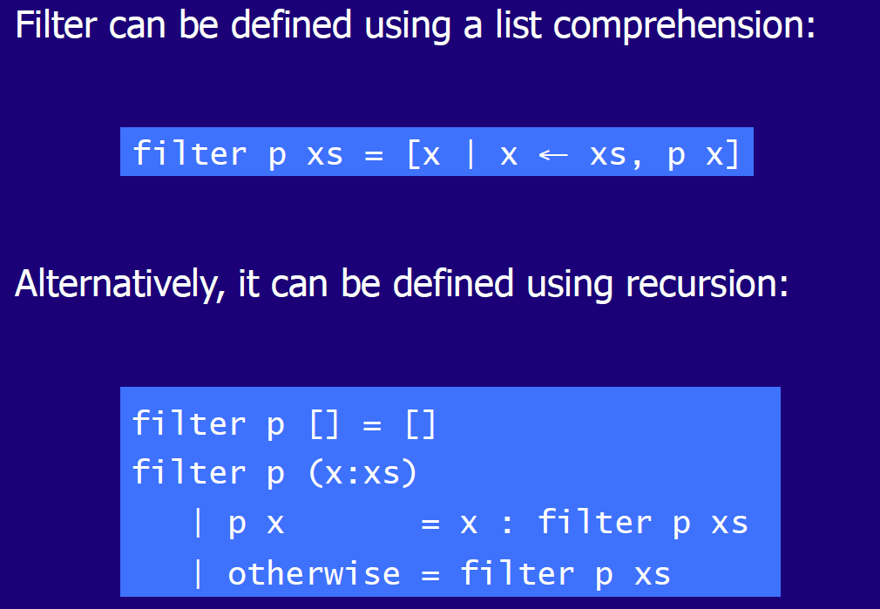

## Foldr Function

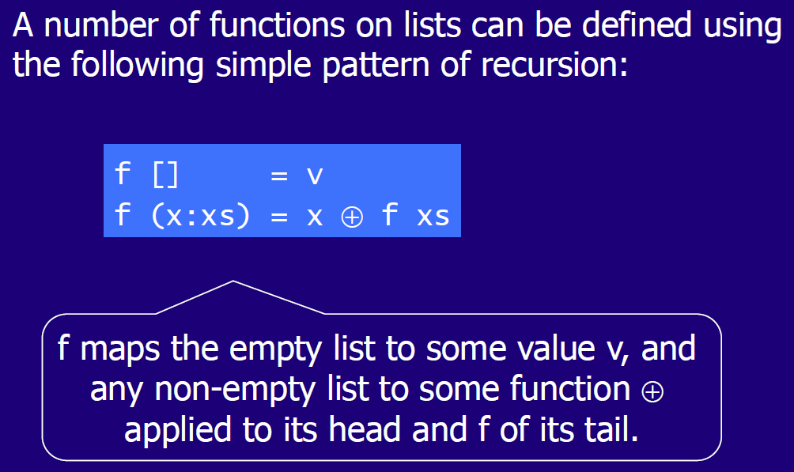

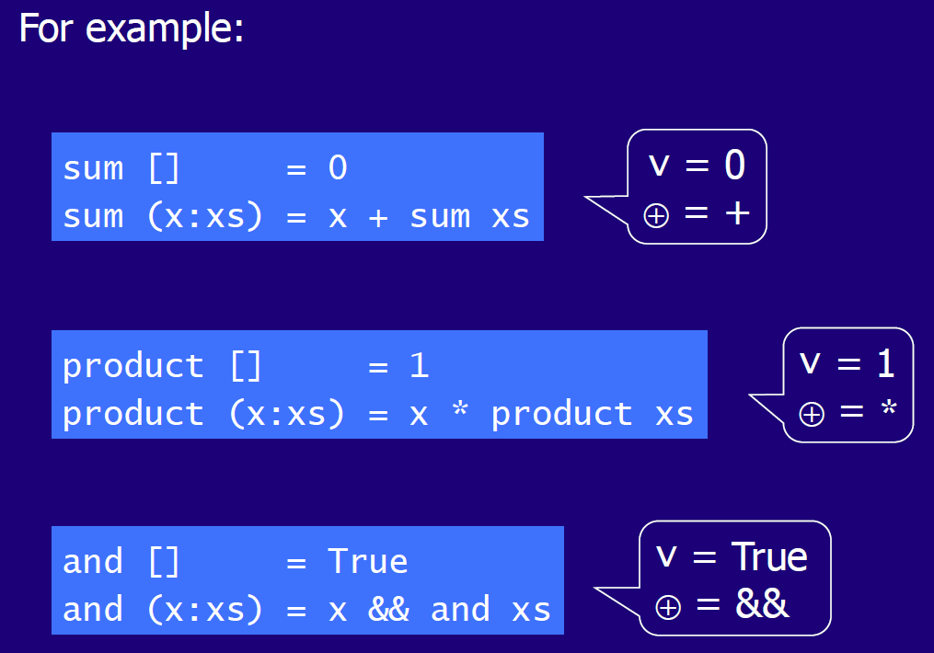

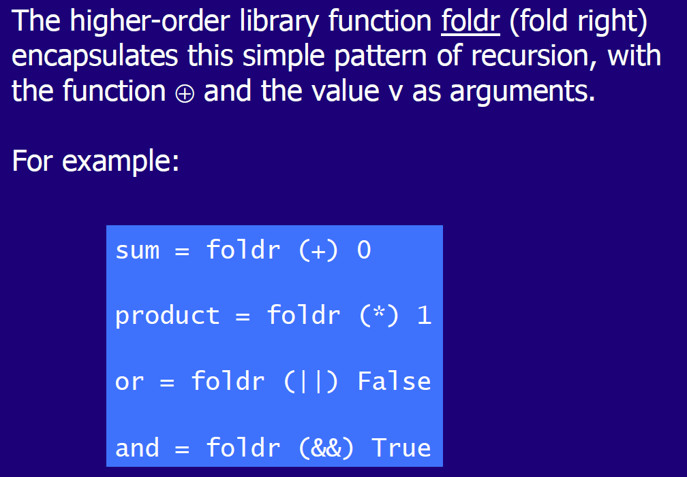

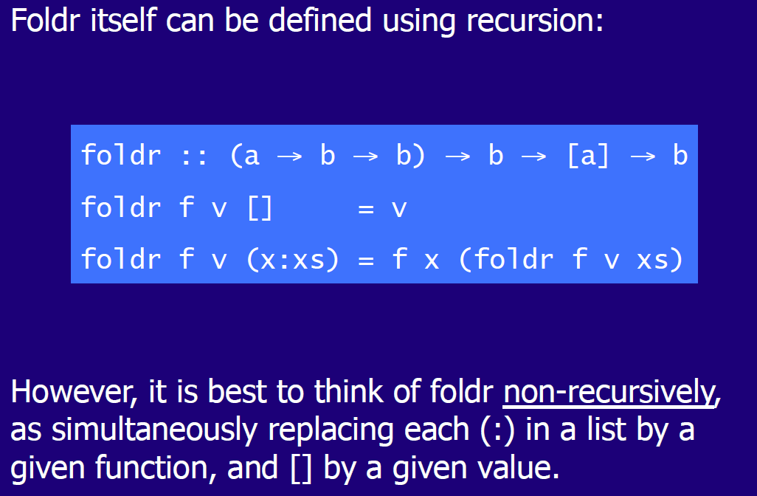

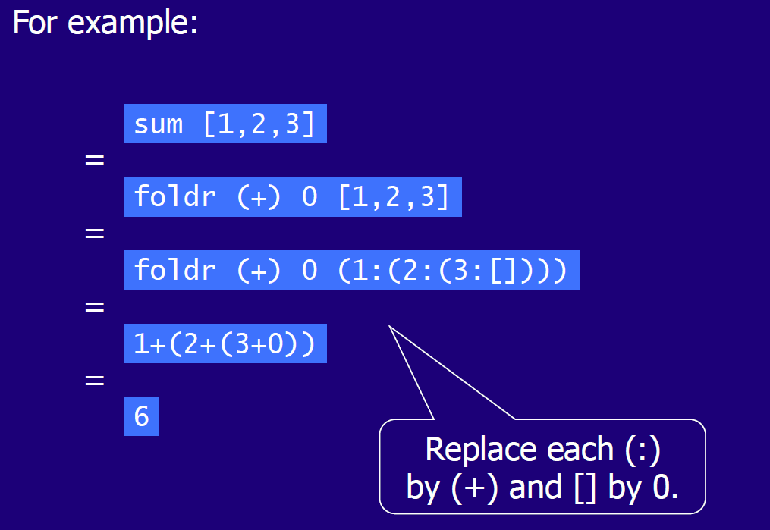

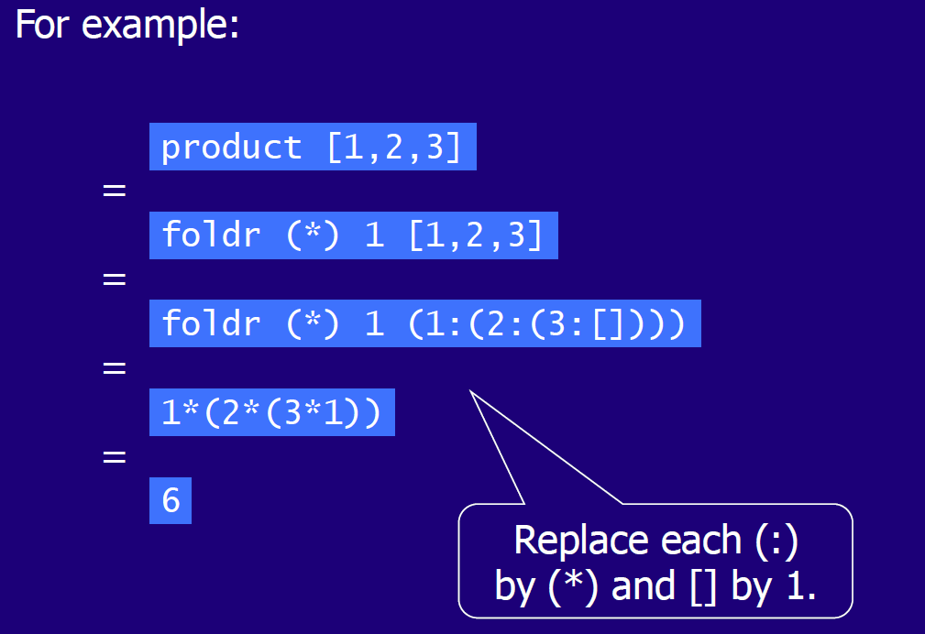

## Other Foldr Examples

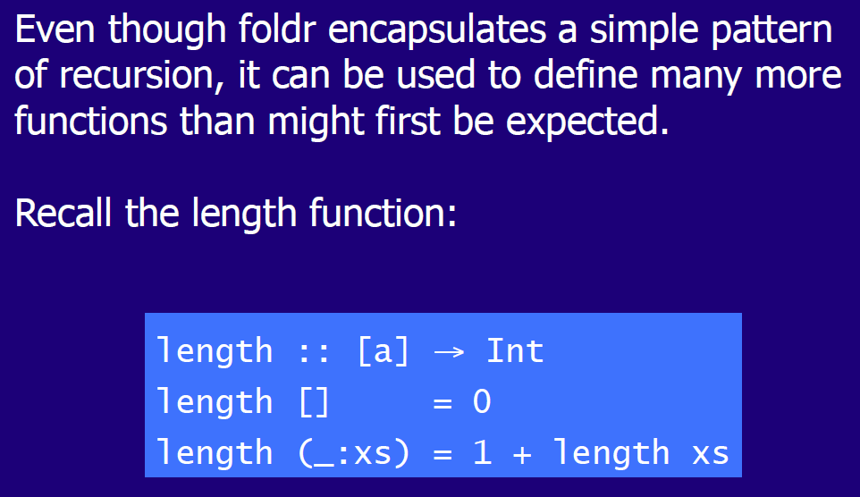

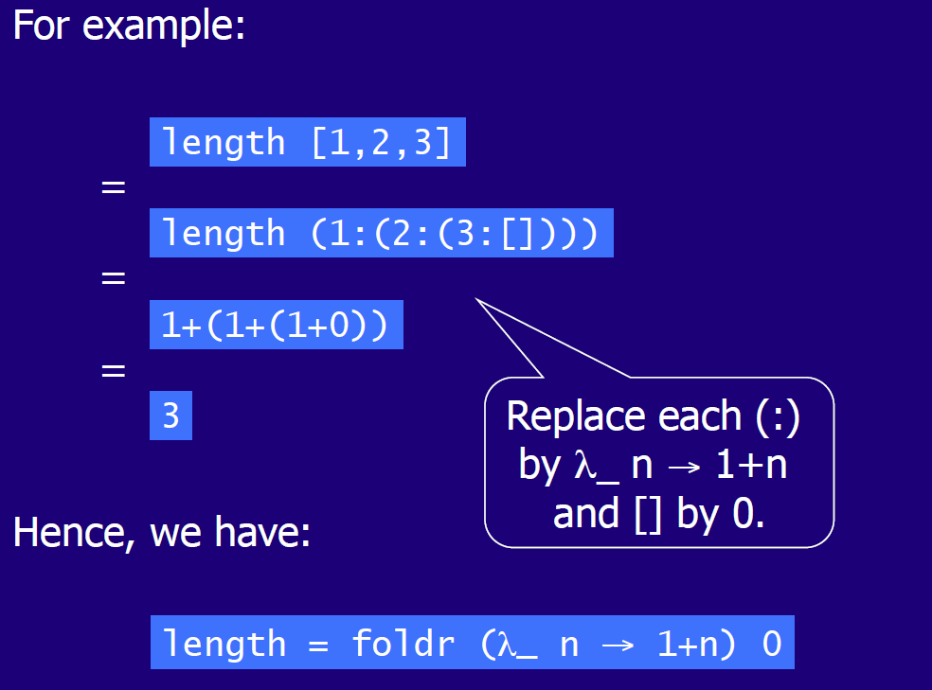

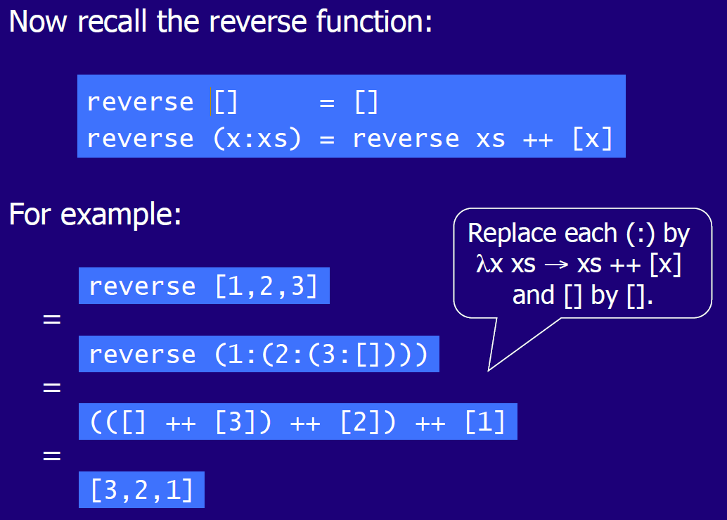

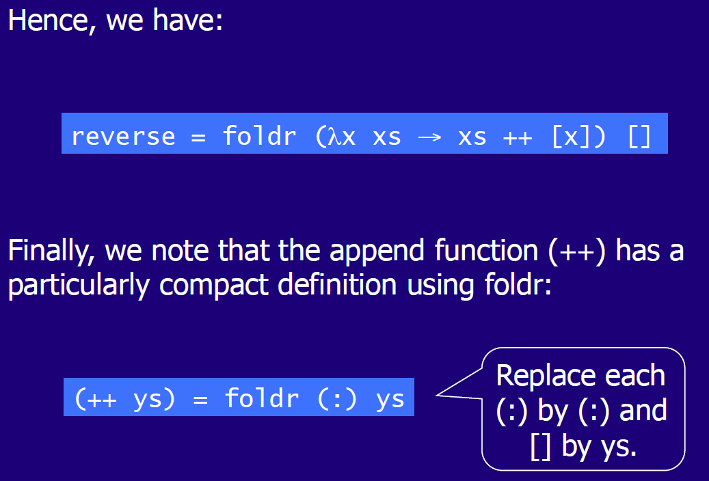

## Why is Foldr useful

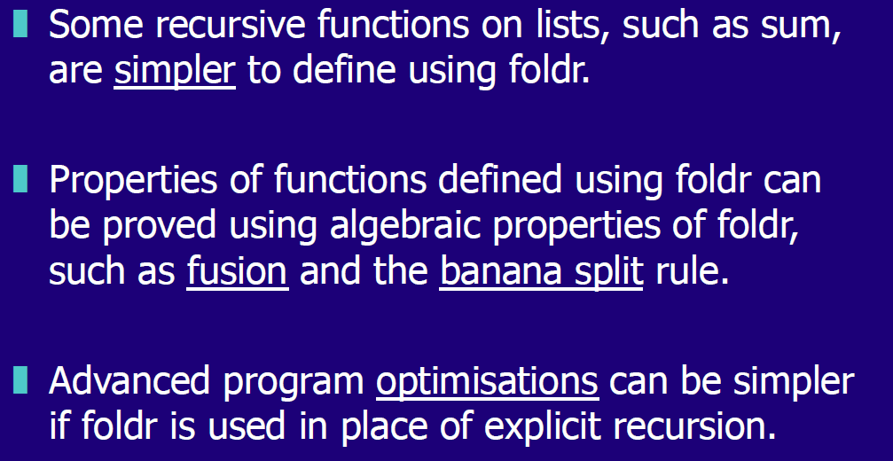

## Other Library Functions

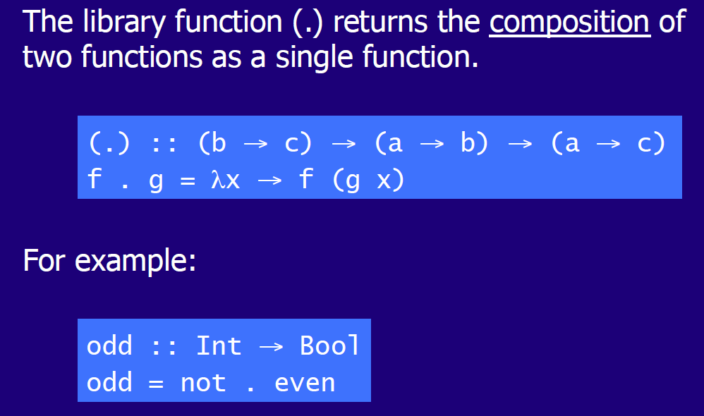

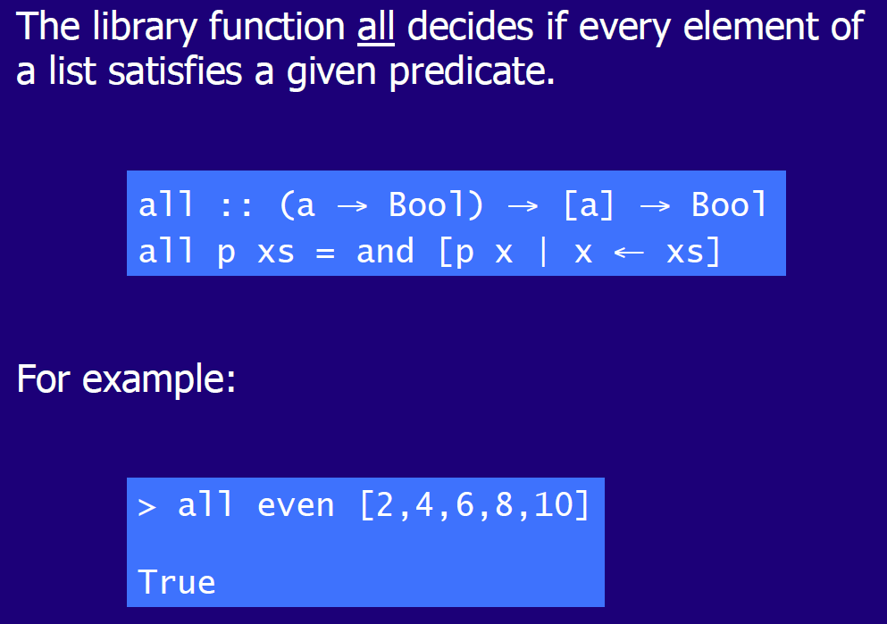

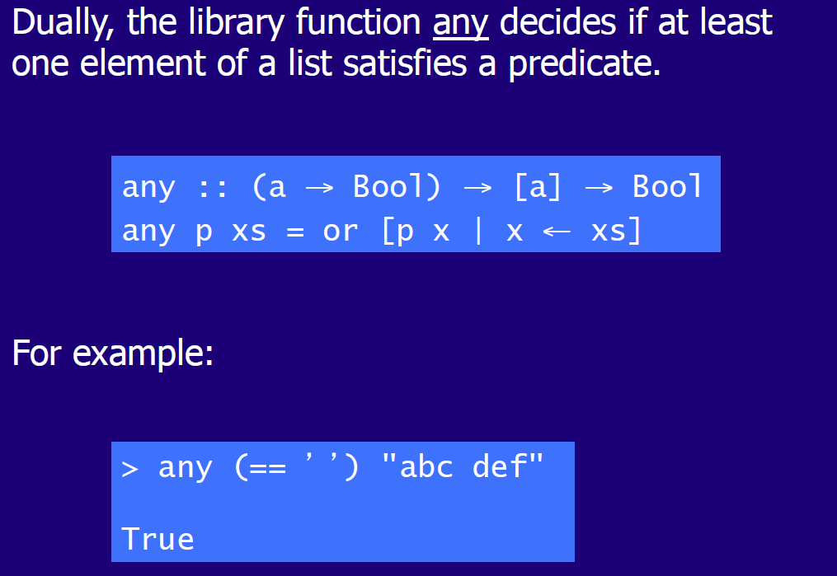

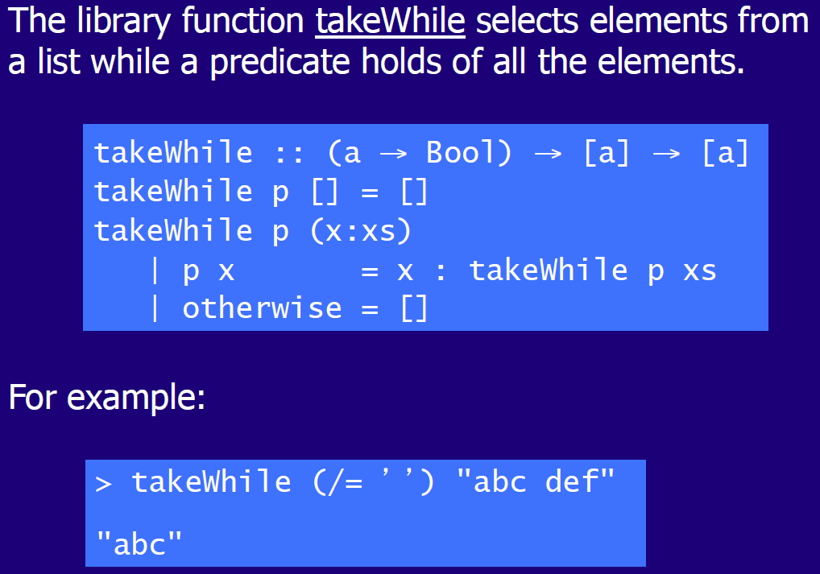

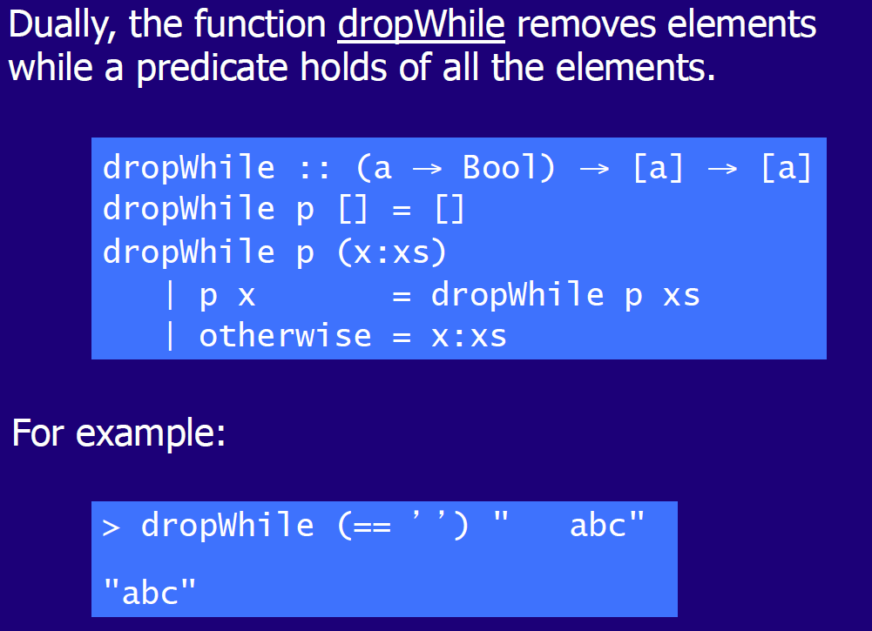

# Woche 15

## Type Declarations

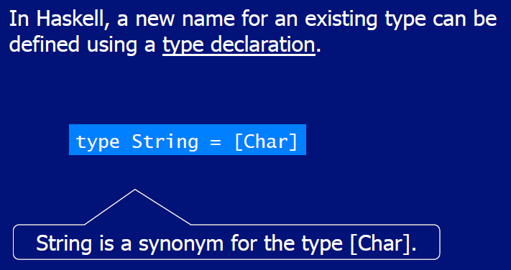

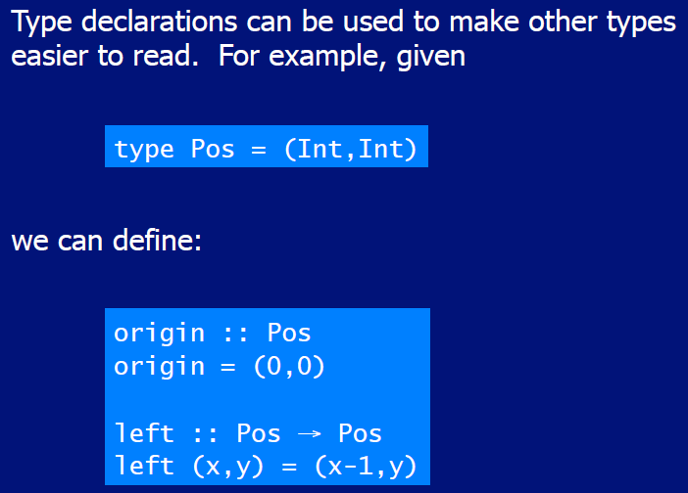

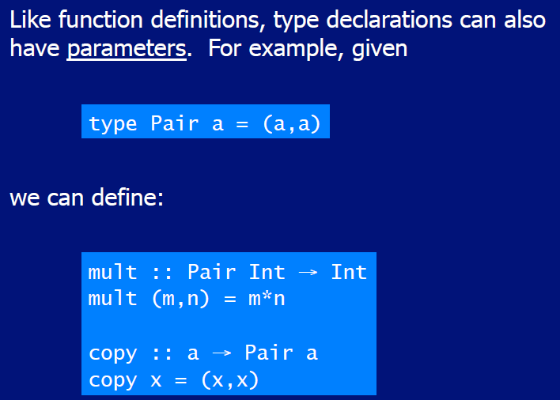

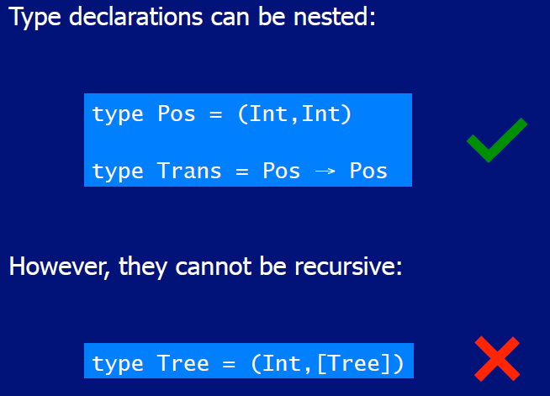

## Data Declarations

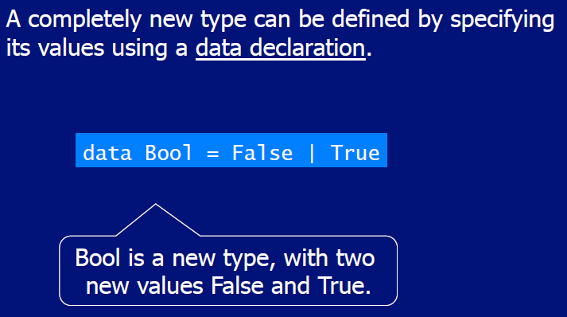

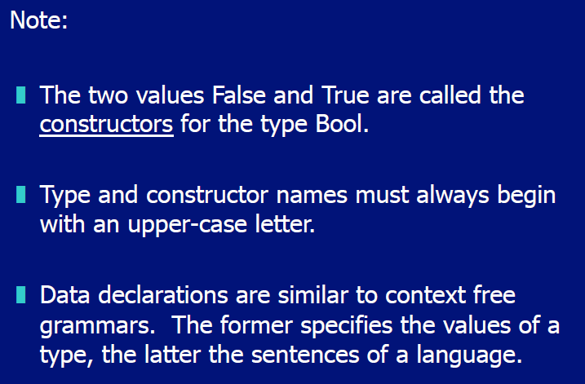

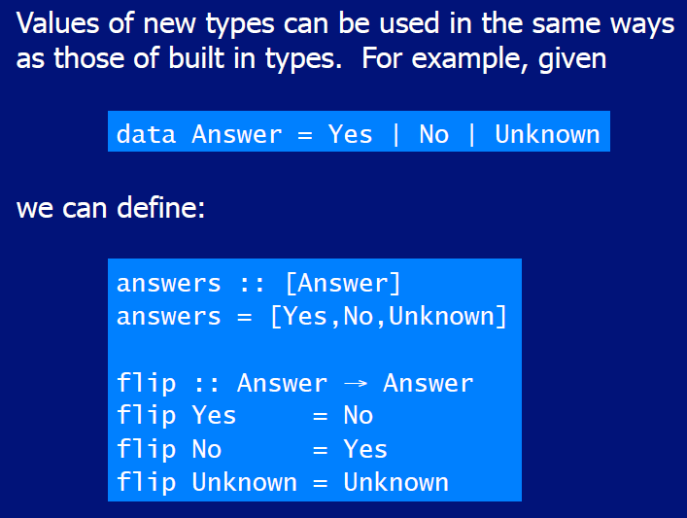

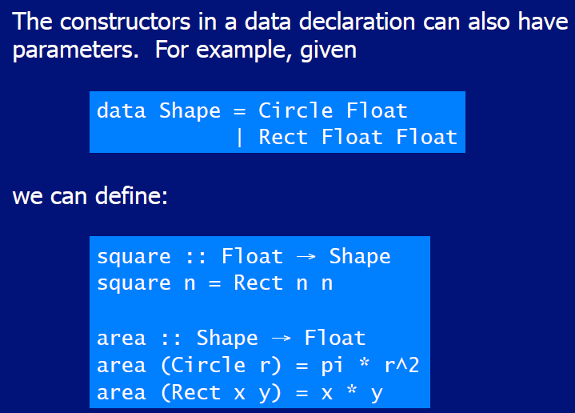

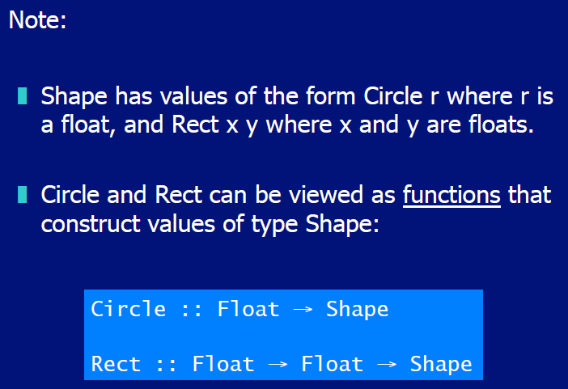

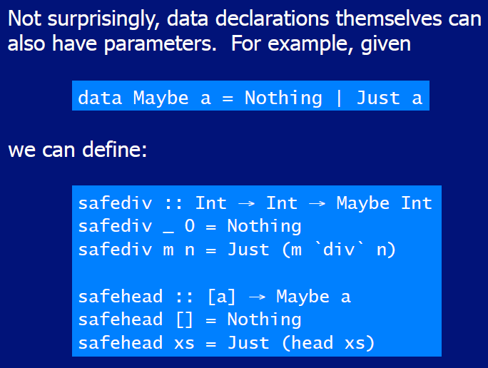

## Recursive Types

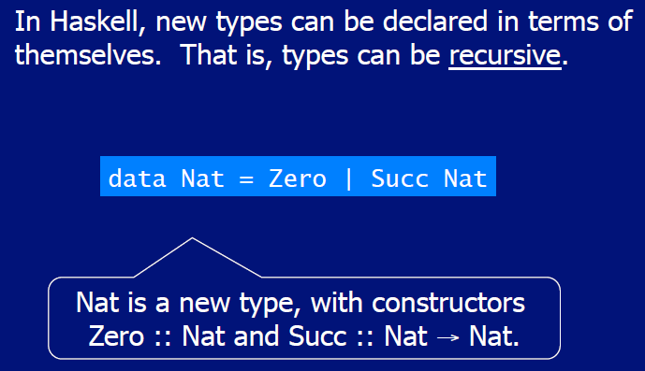

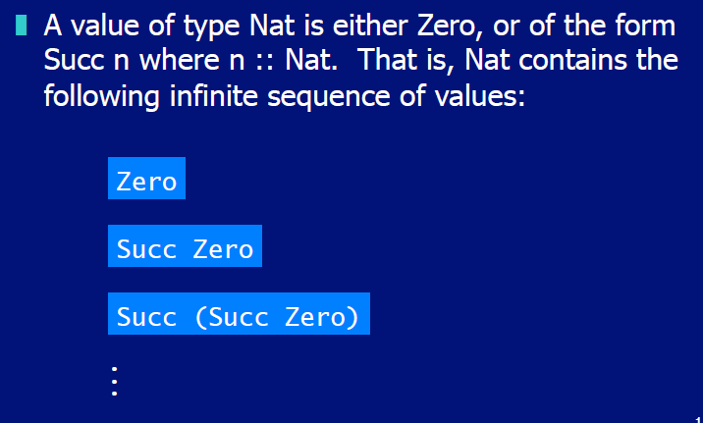

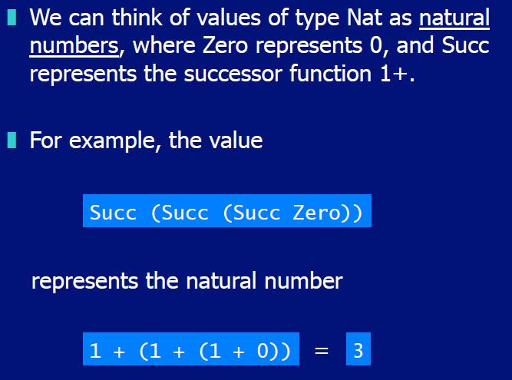

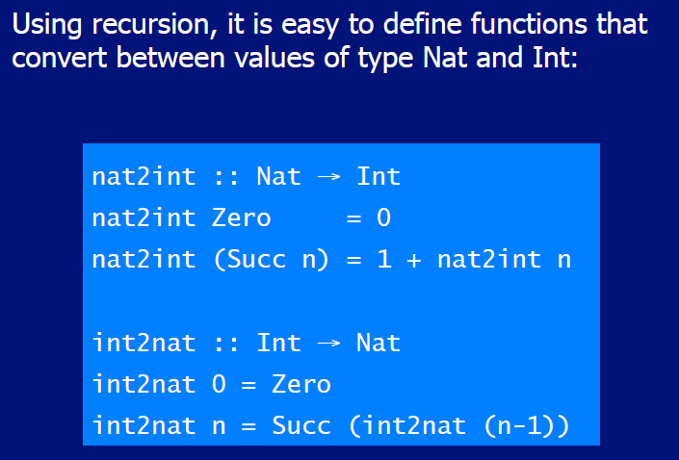

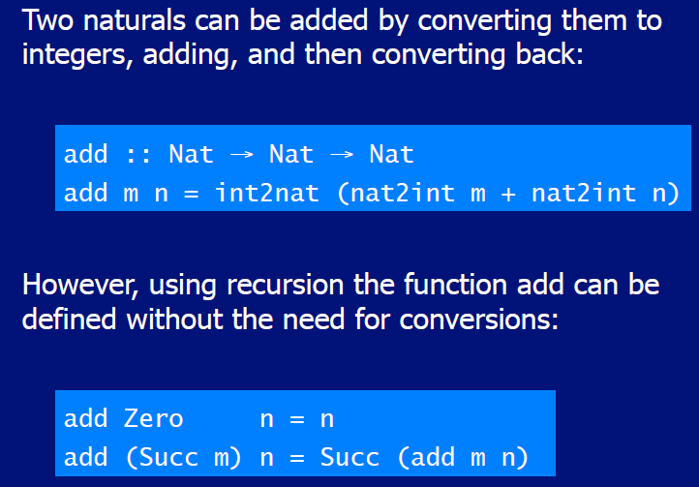

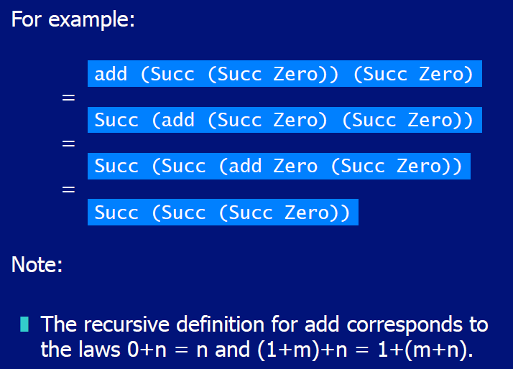

## Arithmetic Expressions

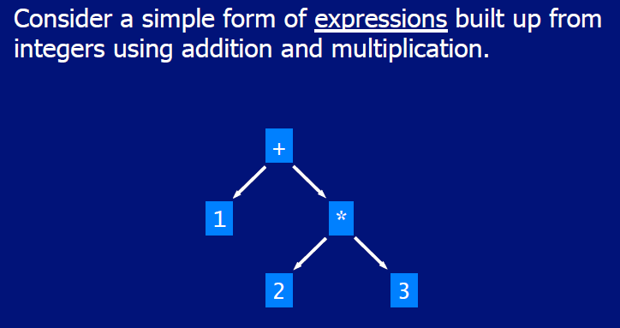

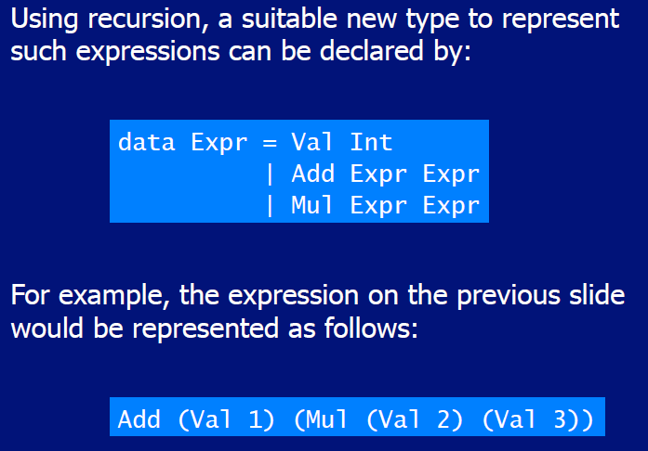

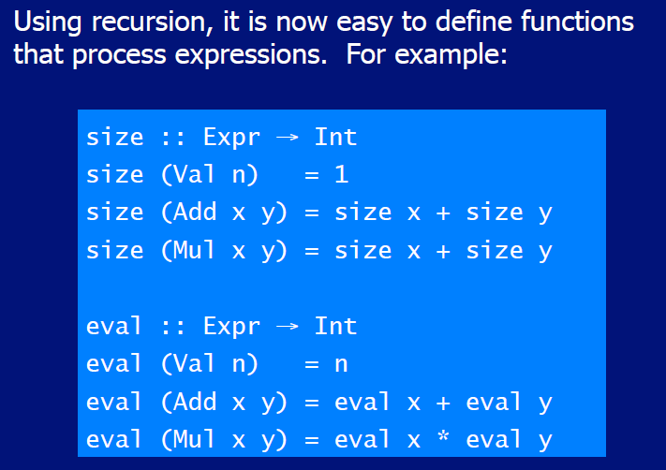

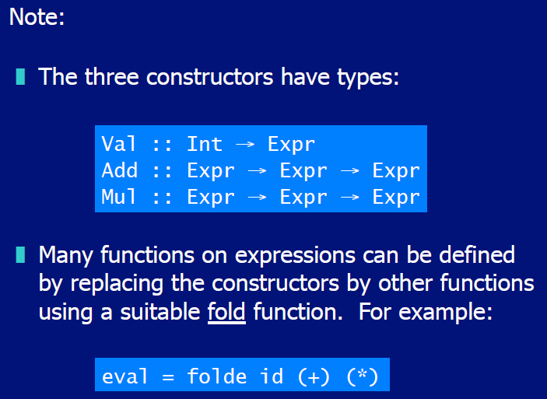

## Binary Trees

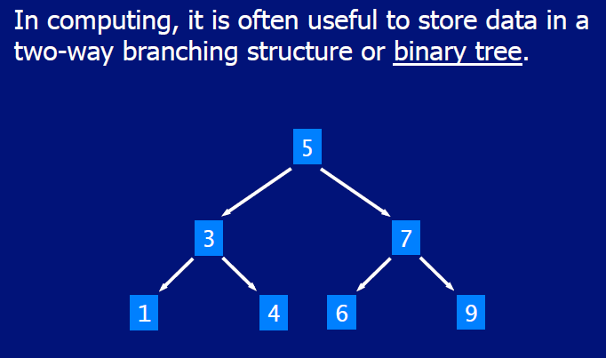

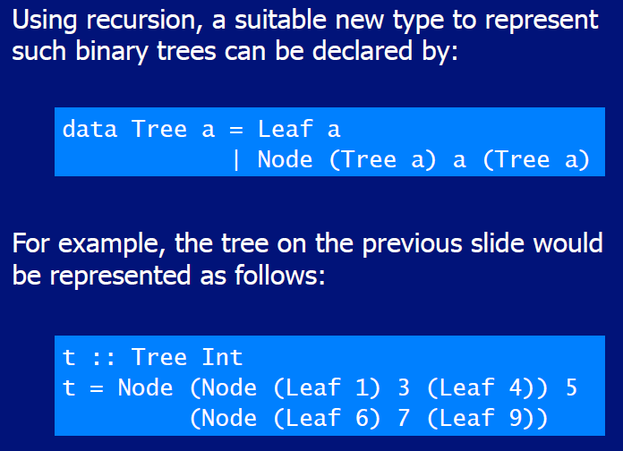

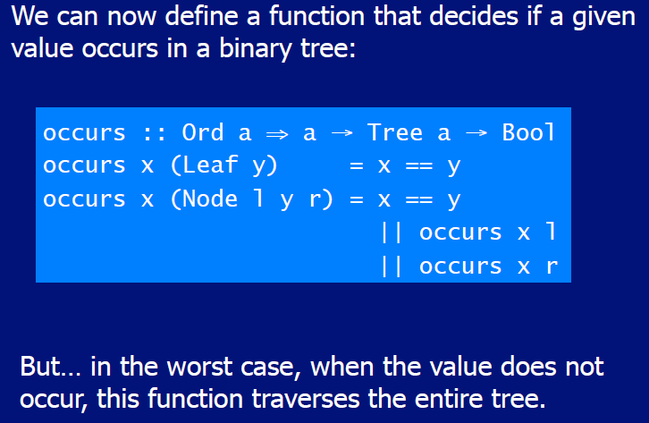

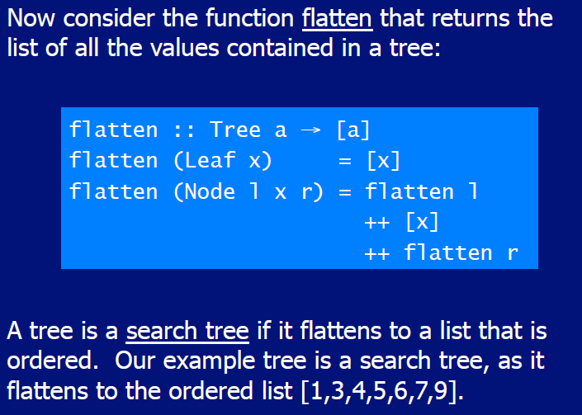

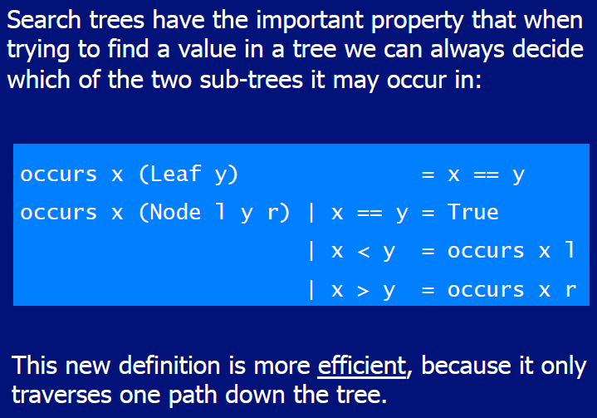

# Woche 16

In Woche 16 fand die zweite Prüfung statt und somit fiel der Unterricht aus.